ENTERPRISE PAYROLL ENGINE, DYNAMIC COMPENSATION
& STATUTORY COMPLIANCE SYSTEM
23CS54C – MODERN WEB TECHNOLOGIES
Submitted by
[STUDENT 2 NAME] [ROLL NO]
In partial fulfillment for the award of the degree
of
BACHELOR OF ENGINEERING/TECHNOLOGY
in
COMPUTER SCIENCE AND ENGINEERING/ INFORMATION TECHNOLOGY

NATIONAL ENGINEERING COLLEGE
(An Autonomous Institution affiliated to Anna University, Chennai)
K.R.NAGAR, KOVILPATTI - 628503
OCTOBER - 2026

NATIONAL ENGINEERING COLLEGE
(An Autonomous Institution affiliated to Anna University, Chennai)
K.R.NAGAR, KOVILPATTI - 628503
BONAFIDE CERTIFICATE
This is to certify that this project report, “Automated Enterprise Payroll Engine with Dynamic Formula Parser & Statutory Compliance Management”, is the bonafide work of [STUDENT 2 NAME] ([ROLL NO]) who carried out the project work under my supervision.
Course Instructor/Guide
Submitted to the 23CS54C – MODERN WEB TECHNOLOGIES Viva-Voce examination held at National Engineering College, K.R.Nagar, Kovilpatti on ____________
Internal Examiner Co Examiner

TABLE OF CONTENTS
CH NO | TITLE | PAGE NO
1 | INTRODUCTION | 4
2 | OBJECTIVES | 6
3 | DESCRIPTION | 7
4 | CLASS DIAGRAM | 9
5 | TABLE STRUCTURES | 13
6 | ER DIAGRAM | 25
7 | TECH STACK | 28
8 | MODULES | 30
9 | CONCLUSION | 96
CHAPTER 1

INTRODUCTION
Paying a mill workforce correctly is harder than it looks from outside. The same organisation pays a general manager a fixed monthly salary split into allowances, a clerk a monthly salary that never varies with attendance, a spinner a wage for each day actually worked, and a monthly-rated worker a salary scaled by the days paid in that month. Some of these employees are covered by provident fund and state insurance and some are not. A worker who comes in on a weekly off is paid differently for that day; a worker present on a national holiday is paid double. On top of the earnings sit recoveries — a loan instalment, a mess bill, a stores issue, an electricity charge, an advance — and on top of those sit the statutory obligations, each with its own wage definition, ceiling and rate.
When this is done by hand or in spreadsheets, three things go wrong. The rules live in people's heads, so a wage structure cannot be changed without re-teaching whoever does the arithmetic. The history is lost, so nobody can say with certainty what an employee's salary was eleven months ago when an arrear has to be worked out. And the statutory returns are assembled separately from the payroll that produced them, so the figures on the provident fund statement and the figures on the payslips drift apart.
It is the second of two co-operating systems that together form the KR Mill Workforce Platform. The first system — Smart Biometric Attendance, Shift Scheduling & Workforce Tracking — turns fingerprint punches into verified daily attendance. This system begins where that one ends: it takes the attendance, leave and incentive figures for a month and turns them into gross pay, deductions, net pay, payslips, bank transfer statements and statutory reports.
At its centre are two engines. The first is a formula engine that lets a salary component be defined as a fixed amount, a percentage of another component, or an expression such as IF(BASIC > 15000, 1800, BASIC * 0.12) — validated before it is saved and evaluated in a controlled context when a salary is assigned. The second is a generation engine that, for each employee and month, selects the salary structure that was in force on the first day of that month, counts the payable days, routes the employee to the calculator that matches how they are paid, applies provident fund and state insurance rules, recovers loans and deductions, and writes a result that carries every component line together with the formula that produced it.
Everything the engine produces is kept with its history. A salary revision closes the previous structure with an end date instead of overwriting it. A generated salary moves through Generated, Approved and Paid, and a paid salary can be neither regenerated nor deleted. The statutory reports read the generated salaries themselves, so the return and the payslip are two views of the same rows. This report documents the design, development and implementation of the payroll system, covering its architecture, data model, algorithms and user interface.
CHAPTER 2

OBJECTIVES
- To Make Wage Structures Configurable: Define earnings and deductions as catalog entries that are fixed, percentage-based or formula-based, so that a new allowance is a configuration change and not a programming task.
- To Evaluate Formulas Safely: Validate every salary formula for dangerous patterns, balanced brackets, known identifiers and correct syntax before it is stored, and evaluate it only against a controlled set of component values, employee attributes and built-in functions.
- To Keep Salary History Intact: Give every salary structure an effective-from and effective-to date and record every revision with its old and new figures, so that the salary in force on any past date can be recovered.
- To Pay Each Class of Employee by Its Own Rule: Route management staff, monthly staff, daily-rated workers and monthly-rated workers — each with or without provident fund cover — to the calculator that reflects how that class is actually paid.
- To Apply Statutory Rules Uniformly: Compute provident fund and employees' state insurance from a single configuration of rates, ceilings and limits shared by every calculator.
- To Recover Loans and Deductions Automatically: Deduct loan instalments and monthly recoveries such as mess, stores, electricity and advances during generation, and advance each loan's repayment position as it is recovered.
- To Handle Supplemental Pay: Bring one-off additional earnings and pay for work on holidays into the same monthly run.
- To Generate Payroll in Bulk and Repeatably: Process a filtered set of employees for one month or a range of months in a single run, reporting what was generated, what was skipped and what failed, employee by employee.
- To Protect Settled Payroll: Move each salary through Generated, Approved and Paid, and refuse to regenerate or delete a salary once it is paid.
- To Make Every Rupee Explainable: Store each component line of a generated salary with its base amount, its calculated amount and the formula text that produced it.
- To Produce Payslips and Bank Statements: Generate a payslip PDF for each employee and a bank transfer statement in PDF and Excel for the whole run.
- To Produce Statutory Reports from the Same Data: Derive the provident fund, state insurance, income tax, professional tax and loan reports directly from the generated salaries, so that returns and payslips cannot disagree.
CHAPTER 3

DESCRIPTION
The Enterprise Payroll Engine, Dynamic Compensation & Statutory Compliance System is a full-stack web application built on React, Node.js, Express and MySQL. It is organised into six major functional areas.
1. Salary Components and the Formula Engine
A salary component is a named, coded earning or deduction — BASIC, HRA, a conveyance allowance, a provident fund deduction. Each component declares how it is calculated: as a fixed amount, as a percentage, or by a formula. It also declares whether it affects gross salary, whether it affects net salary, whether it is taxable and whether it is statutory, and the order in which it is displayed. When a formula is entered, the formula evaluator checks it in four steps before the component is saved: a scan for dangerous patterns such as eval, require, process and prototype access; a check that brackets balance; a check that every identifier is a known component code, employee attribute, built-in function or permitted method; and a syntax check in strict mode. A separate formula library stores named, versioned formulas with a structured JSON form, the designations and employee types they apply to, a priority and a validity period, built through a visual formula builder.
2. Employee Salary Master and Revisions
An employee's salary structure is a salary master row with a set of component rows beneath it. Assigning a salary evaluates the components in three passes — fixed amounts first, then percentages of the components already known, then formulas, each of which may refer to any component value computed so far and to the employee's designation, grade, department, experience, employee type, location and age. Gross salary is the sum of earnings that affect gross; net is gross less deductions; monthly and annual cost-to-company follow. A revision does not edit the current structure. It closes it — setting its effective-to date to the day before the revision and its status to Superseded — creates a new Active structure linked to the old one, and writes a revision history row holding the old and new basic, gross and cost-to-company figures, the increment amount and the increment percentage. All of this happens inside a single database transaction. Employer grades and employment types are maintained alongside as the classifications that decide how an employee is paid.
3. Loans and Deductions
A loan is recorded with its type, amount, interest rate, sanction date, start date and number of instalments, from which the instalment amount is derived. It begins as pending, becomes active on approval, and completes when its last instalment is recovered. Recurring and one-time recoveries — mess, stores, electricity, advances and others — are entered per employee per month, with at most one entry of each type for an employee in a month. A consolidated deduction report pivots these by employee, with one column per deduction type.
4. Supplemental Earnings
Additional salary records a one-off earning for an employee in a month against a salary component, with a number of days and an amount, and a generated ticket number. Holiday salary identifies the employees who were present on a declared holiday and, for workers, computes holiday pay from their BASIC component — a full day's basic for a full day and half for a half day — and tracks each entry from Pending to Paid, individually or all at once.
5. Batch Salary Generation
This is the core of the system. A run is requested for a company and a month — or a range of months — optionally narrowed by employee, department, category, employee type, working type, provident fund status, or management versus other staff. For each employee the engine skips the month if it is already Paid; selects the most recent Active salary master whose effective date is on or before the first day of the pay period; counts present, absent, paid-leave, unpaid-leave, holiday, week-off, week-off-worked and national or festival holiday days from the attendance and approved leave records; fetches the attendance incentive, loan instalment, monthly deductions and additional salary; and then routes the employee to one of six calculators. Provident fund and state insurance are applied from shared configuration, deductions are totalled, net pay is computed, and the result is written as one header row and one detail row per component. Errors are collected per employee so that one failure does not stop the run.
6. Payslips, Bank Disbursement and Statutory Reporting
The salary report lists generated salaries with filters and totals — including separate PF and non-PF registers — and exports to Excel and PDF. The payslip is generated as a PDF for an individual employee, with net pay also written in words. The bank statement lists each employee's bank account, IFSC code and net pay for the run, in PDF and Excel. The statutory reports read the same generated salaries: the provident fund report derives the EPF wage, the pension and insurance wages capped at the statutory ceiling, the employee contribution and the employer's pension and provident fund shares, with non-contributory days; the state insurance report derives employee and employer contributions; the income tax report totals tax deducted per employee; the professional tax report applies half-yearly slabs to six months of gross pay; and the loan report shows outstanding positions. Access is secured with bcrypt password hashing, JWT bearer tokens and role-based route guards.
CHAPTER 4

CLASS DIAGRAM
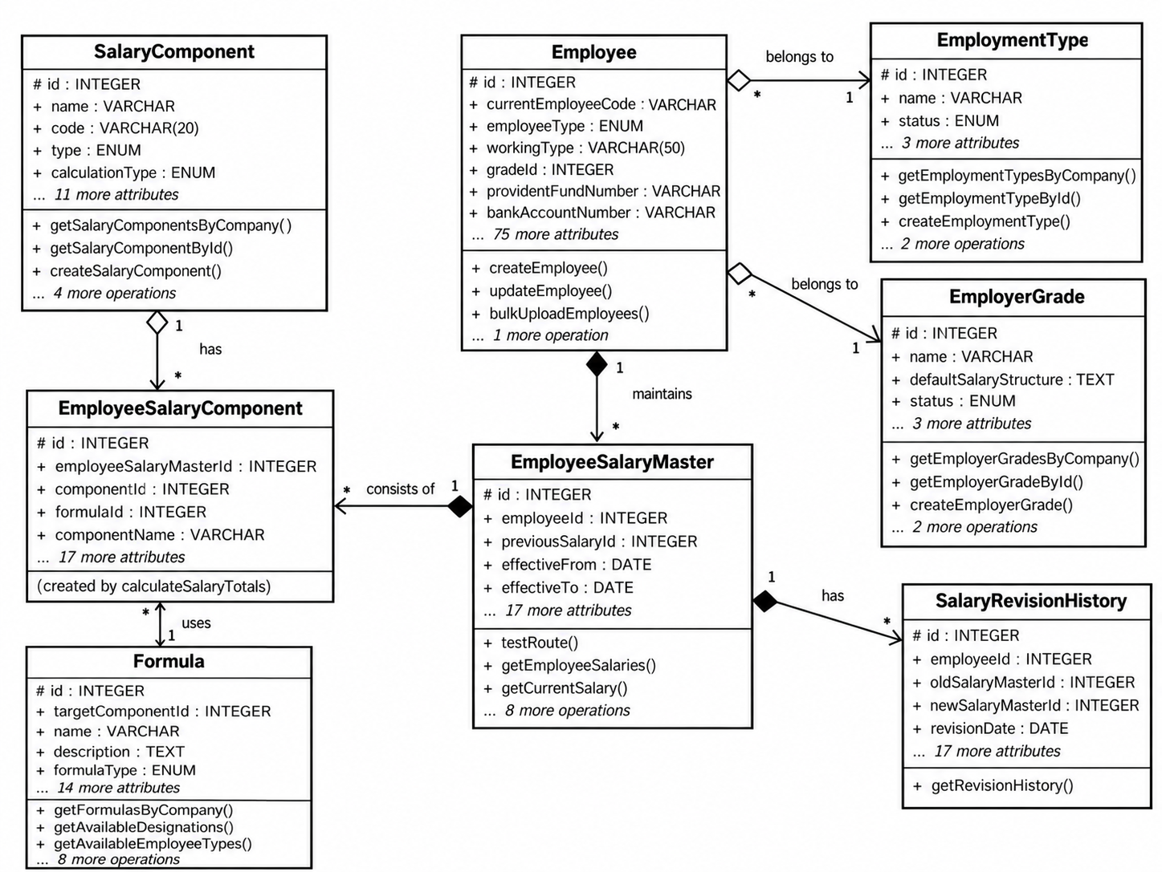
Fig 4.1 Class diagram – salary structure classes
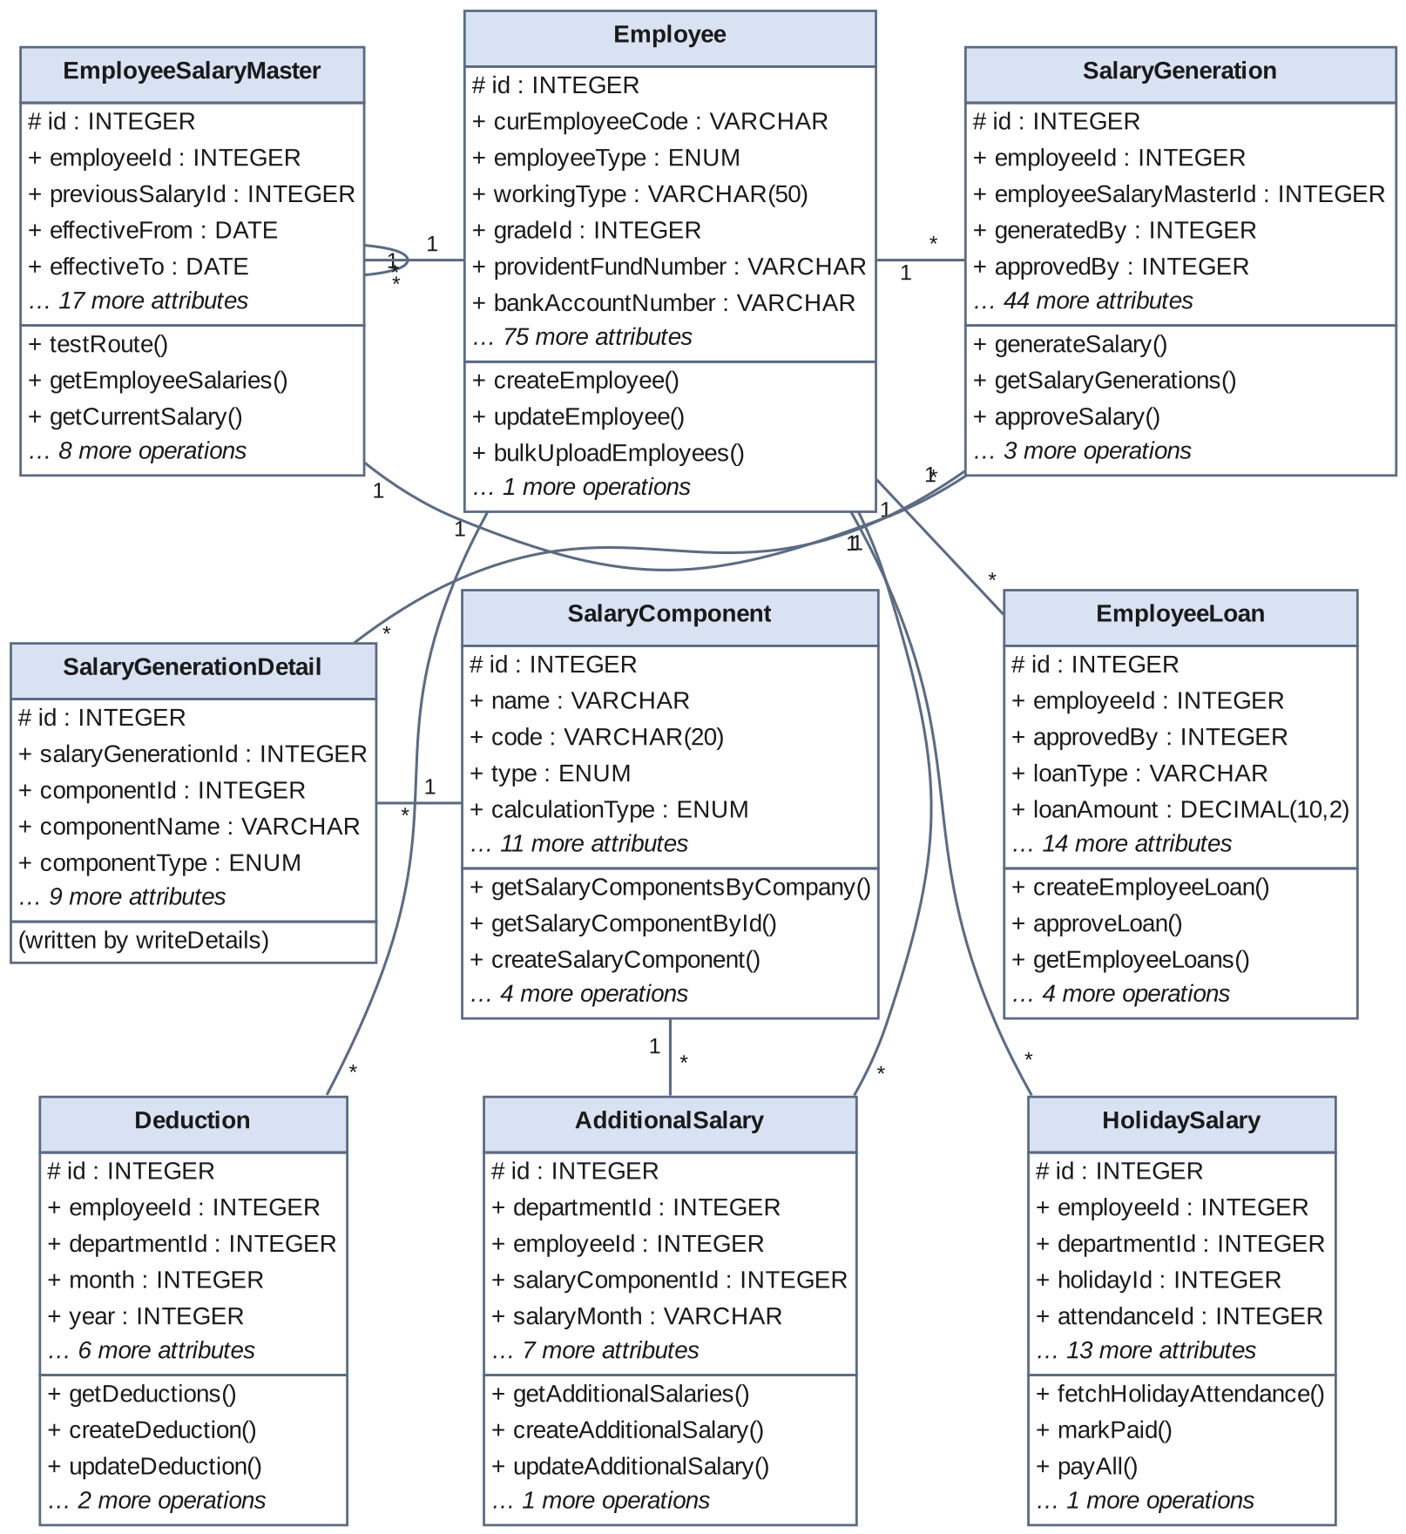
Fig 4.2 Class diagram – payroll processing classes
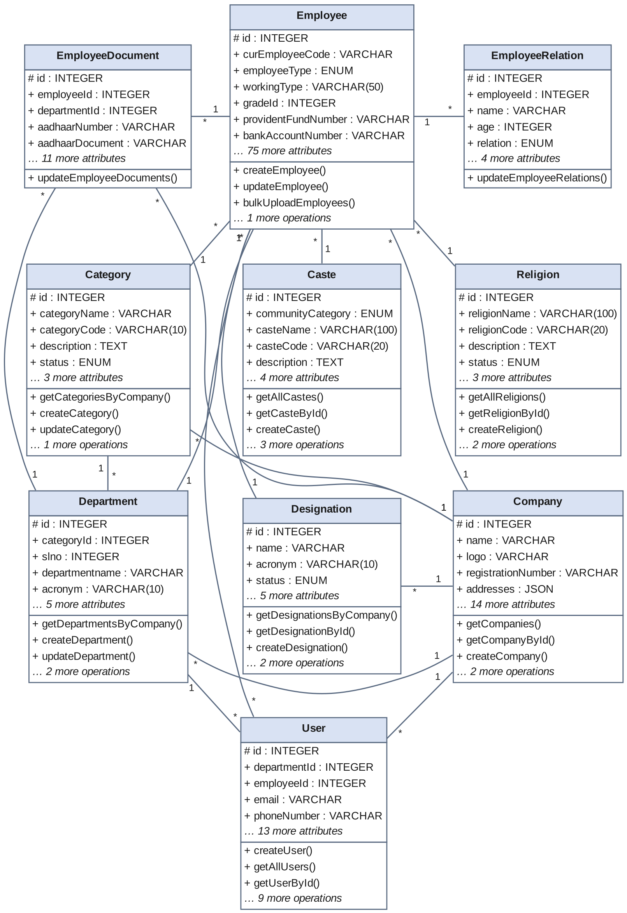
Fig 4.3 Class diagram – employee profile and compliance master classes
The class diagrams show the Sequelize model classes of the payroll system and the associations declared between them. Each class box lists key attributes of the model and the main operations exposed by its controller; 1 and * mark the one and many ends of each association. Employee sits at the centre: EmployeeSalaryMaster, SalaryGeneration, EmployeeLoan, Deduction, AdditionalSalary, HolidaySalary, EmployeeDocument and EmployeeRelation all hold a foreign key to it. EmployeeSalaryMaster composes EmployeeSalaryComponent, each of which refers to a SalaryComponent and optionally to a Formula; it also refers to itself through previousSalaryId, forming the revision chain that SalaryRevisionHistory records. SalaryGeneration composes SalaryGenerationDetail and points back to the EmployeeSalaryMaster it was generated from. Company is the tenant root.
CHAPTER 5

TABLE STRUCTURES
The system uses 23 tables in the shared MySQL schema. Their structures, taken from the Sequelize model definitions, are shown below.
5.1 Shared Master Tables
companies :
Field | Type | Null | Key | Default / Extra
id | INTEGER | NO | PRI | auto_increment
name | VARCHAR(255) | NO | UNI
logo | VARCHAR(255) | YES
registrationNumber | VARCHAR(255) | YES | UNI
addresses | JSON | YES |  | {}
phone | VARCHAR(255) | YES
email | VARCHAR(255) | YES
website | VARCHAR(255) | YES
tin | VARCHAR(255) | YES
pan | VARCHAR(255) | YES
gst | VARCHAR(255) | YES
bankName | VARCHAR(255) | YES
bankAccountNumber | VARCHAR(255) | YES
bankIfscCode | VARCHAR(255) | YES
financialYearStart | DATE | YES
financialYearEnd | DATE | YES
status | ENUM(Active, Inactive) | NO |  | Active
createdAt | DATETIME | NO
updatedAt | DATETIME | NO
Indexes: primary key only
departments :
Field | Type | Null | Key | Default / Extra
id | INTEGER | NO | PRI | auto_increment
slno | INTEGER | NO
departmentname | VARCHAR(255) | NO
acronym | VARCHAR(10) | NO
isTrain | TINYINT(1) | NO |  | 0
strengthRequired | DECIMAL(10,2) | NO |  | 0
companyId | INTEGER | NO | FK → companies
categoryId | INTEGER | NO | FK → category
createdAt | DATETIME | NO
updatedAt | DATETIME | NO
Indexes: primary key only
designations :
Field | Type | Null | Key | Default / Extra
id | INTEGER | NO | PRI | auto_increment
name | VARCHAR(255) | NO
acronym | VARCHAR(10) | NO
status | ENUM(Active, Inactive) | NO |  | Active
createdBy | INTEGER | YES |  | 1
updatedBy | INTEGER | YES |  | 1
companyId | INTEGER | NO | FK → companies
createdAt | DATETIME | NO
updatedAt | DATETIME | NO
Indexes: primary key only
category :
Field | Type | Null | Key | Default / Extra
id | INTEGER | NO | PRI | auto_increment
categoryName | VARCHAR(255) | NO
categoryCode | VARCHAR(10) | NO
description | TEXT | YES
status | ENUM(Active, Inactive) | NO |  | Active
companyId | INTEGER | NO | FK → companies
createdAt | DATETIME | NO
updatedAt | DATETIME | NO
Indexes: primary key only
castes :
Field | Type | Null | Key | Default / Extra
id | INTEGER | NO | PRI | auto_increment
companyId | INTEGER | NO | FK → companies
communityCategory | ENUM(General, BC, OBC, MBC, SC, ST, OC) | YES
casteName | VARCHAR(100) | NO
casteCode | VARCHAR(20) | YES
description | TEXT | YES
status | ENUM(Active, Inactive) | NO |  | Active
createdAt | DATETIME | NO
updatedAt | DATETIME | NO
Indexes: UNIQUE (companyId, casteCode); UNIQUE (companyId, communityCategory, casteName)
religions :
Field | Type | Null | Key | Default / Extra
id | INTEGER | NO | PRI | auto_increment
companyId | INTEGER | NO
religionName | VARCHAR(100) | NO
religionCode | VARCHAR(20) | NO
description | TEXT | YES
status | ENUM(Active, Inactive) | NO |  | Active
createdAt | DATETIME | NO
updatedAt | DATETIME | NO
Indexes: UNIQUE (companyId, religionCode); UNIQUE (companyId, religionName)
users :
Field | Type | Null | Key | Default / Extra
id | INTEGER | NO | PRI | auto_increment
email | VARCHAR(255) | NO | UNI
phoneNumber | VARCHAR(255) | NO | UNI
password | VARCHAR(255) | NO
role | ENUM(Staff, Admin, Department Admin, Super Admin, HR) | NO |  | Staff
status | ENUM(Active, Inactive) | NO |  | Active
companyId | INTEGER | NO | FK → companies
departmentId | INTEGER | YES | FK → departments
firstName | VARCHAR(255) | YES
lastName | VARCHAR(255) | YES
lastLogin | DATETIME | YES
passwordResetToken | VARCHAR(255) | YES
passwordResetExpires | DATETIME | YES
employeeId | INTEGER | YES | FK → employees
createdBy | INTEGER | YES | FK → users
updatedBy | INTEGER | YES | FK → users
createdAt | DATETIME | NO
updatedAt | DATETIME | NO
Indexes: UNIQUE (email); UNIQUE (phoneNumber); INDEX (companyId); INDEX (departmentId); INDEX (role)
5.2 Employee Profile Tables
employees :
Field | Type | Null | Key | Default / Extra
id | INTEGER | NO | PRI | auto_increment
curEmployeeCode | VARCHAR(255) | NO | UNI
newEmployeeCode | VARCHAR(255) | YES
firstName | VARCHAR(255) | NO
middleName | VARCHAR(255) | YES
lastName | VARCHAR(255) | NO
dateOfBirth | DATE | NO
adolescenceCertificate | VARCHAR(255) | YES
adolescenceCertificateNumber | VARCHAR(255) | YES
adolescenceCertificateValidity | DATETIME | YES
gender | ENUM(Male, Female, Other) | NO
bloodGroup | ENUM(A+, A-, B+, B-, O+, O-, AB+, AB-) | YES
maritalStatus | ENUM(Single, Married, Divorced, Widowed) | YES
profilePhoto | VARCHAR(255) | YES
categoryId | INTEGER | YES | FK → category
casteId | INTEGER | YES | FK → castes
religionId | INTEGER | YES | FK → religions
experience | INTEGER | YES |  | 0
personalEmail | VARCHAR(255) | NO
officialEmail | VARCHAR(255) | YES
mobileNumber | VARCHAR(255) | NO
alternateMobile | VARCHAR(255) | YES
emergencyContactName | VARCHAR(255) | YES
emergencyContactNumber | VARCHAR(255) | YES
emergencyContactRelationship | VARCHAR(255) | YES
currentAddressLine1 | VARCHAR(255) | NO
currentAddressLine2 | VARCHAR(255) | YES
currentCity | VARCHAR(255) | NO
currentState | VARCHAR(255) | NO
currentPincode | VARCHAR(255) | NO
currentCountry | VARCHAR(255) | NO
permanentAddressLine1 | VARCHAR(255) | YES
permanentAddressLine2 | VARCHAR(255) | YES
permanentCity | VARCHAR(255) | YES
permanentState | VARCHAR(255) | YES
permanentPincode | VARCHAR(255) | YES
permanentCountry | VARCHAR(255) | YES
designationId | INTEGER | NO | FK → designations
employmentTypeId | INTEGER | NO | FK → employment_types
employeeType | ENUM(Permanent, Contract, Temporary, Intern, Staff, Worker) | NO
dateOfJoining | DATE | NO
dateOfRejoining | DATE | YES
confirmationDate | DATE | YES
relievingDate | DATETIME | YES
leavingReason | TEXT | YES
probationPeriod | INTEGER | YES |  | 0
reportingManagerId | INTEGER | YES | FK → employees
workLocation | VARCHAR(255) | YES
employmentStatus | ENUM(Active, Resigned, Terminated, On Leave, Retired) | NO |  | Active
referencePersonName | VARCHAR(255) | YES
referencePersonContact | VARCHAR(255) | YES
shiftTypeId | INTEGER | YES | FK → shift_types
leavePolicyId | INTEGER | YES | FK → leave_policies
weeklyOff | ENUM(Sunday, Monday, Tuesday, Wednesday, Thursday, Friday, Saturday) | YES |  | Sunday
isOvertimeApplicable | TINYINT(1) | NO |  | 0
isLeaveApplicable | TINYINT(1) | NO |  | 1
biometricDeviceId | INTEGER | YES | FK → biometric_devices
curBiometricEnrollmentId | VARCHAR(255) | YES
newBiometricEnrollmentId | VARCHAR(255) | YES
basicSalary | DECIMAL(10,2) | YES |  | 0
providentFundNumber | VARCHAR(255) | YES
bankName | VARCHAR(255) | YES
bankAccountNumber | VARCHAR(255) | YES
ifscCode | VARCHAR(255) | YES
bankBranch | VARCHAR(255) | YES
paymentMode | ENUM(Bank Transfer, Cash, Cheque) | YES |  | Bank Transfer
uanNumber | VARCHAR(255) | YES
epfNumber | VARCHAR(255) | YES
esiNumber | VARCHAR(255) | YES
isTransportRequired | TINYINT(1) | NO |  | 0
busId | INTEGER | YES | FK → buses
pickupPoint | VARCHAR(255) | YES
isHostel | TINYINT(1) | NO |  | 0
isTrainee | TINYINT(1) | NO |  | 0
status | ENUM(Active, Inactive) | NO |  | Active
companyId | INTEGER | NO | FK → companies
workingType | VARCHAR(50) | YES
departmentId | INTEGER | NO | FK → departments
gradeId | INTEGER | YES | FK → employer_grades
workload | DECIMAL(10,2) | YES
createdAt | DATETIME | NO
updatedAt | DATETIME | NO
Indexes: primary key only
employee_documents :
Field | Type | Null | Key | Default / Extra
id | INTEGER | NO | PRI | auto_increment
employeeId | INTEGER | NO | FK → employees
companyId | INTEGER | NO | FK → companies
departmentId | INTEGER | YES | FK → departments
aadhaarNumber | VARCHAR(255) | YES
aadhaarDocument | VARCHAR(255) | YES
panNumber | VARCHAR(255) | YES
panDocument | VARCHAR(255) | YES
passportNumber | VARCHAR(255) | YES
passportDocument | VARCHAR(255) | YES
voterIdNumber | VARCHAR(255) | YES
voterIdDocument | VARCHAR(255) | YES
drivingLicenseNumber | VARCHAR(255) | YES
drivingLicenseDocument | VARCHAR(255) | YES
createdAt | DATETIME | NO
updatedAt | DATETIME | NO
Indexes: primary key only
employee_relations :
Field | Type | Null | Key | Default / Extra
id | INTEGER | NO | PRI | auto_increment
employeeId | INTEGER | NO | FK → employees
name | VARCHAR(255) | NO
age | INTEGER | YES
relation | ENUM(Father, Mother, Spouse, Son, Daughter, Brother, Sister, Other) | NO
occupation | VARCHAR(255) | YES
salary | DECIMAL(10,2) | YES |  | 0
createdAt | DATETIME | NO
updatedAt | DATETIME | NO
Indexes: primary key only
5.3 Salary Component and Formula Tables
salary_components :
Field | Type | Null | Key | Default / Extra
id | INTEGER | NO | PRI | auto_increment
name | VARCHAR(255) | NO
code | VARCHAR(20) | NO
type | ENUM(Earning, Deduction) | NO
calculationType | ENUM(Fixed, Percentage, Formula) | NO |  | Fixed
percentage | DECIMAL(5,2) | YES
formula | TEXT | YES
affectsGrossSalary | TINYINT(1) | NO |  | 1
affectsNetSalary | TINYINT(1) | NO |  | 1
isTaxable | TINYINT(1) | NO |  | 1
isStatutory | TINYINT(1) | NO |  | 0
displayOrder | INTEGER | NO |  | 0
status | ENUM(Active, Inactive) | NO |  | Active
companyId | INTEGER | NO | FK → companies
createdAt | DATETIME | NO
updatedAt | DATETIME | NO
Indexes: UNIQUE (code, companyId)
formulas :
Field | Type | Null | Key | Default / Extra
id | INTEGER | NO | PRI | auto_increment
name | VARCHAR(255) | NO
description | TEXT | YES
formulaType | ENUM(Simple, Conditional, Complex) | NO |  | Simple
formulaExpression | TEXT | NO
formulaJson | JSON | NO
variables | JSON | YES
targetComponentId | INTEGER | YES | FK → salary_components
applicableDesignations | JSON | YES |  | []
applicableEmployeeTypes | JSON | YES |  | []
isActive | TINYINT(1) | NO |  | 1
validFrom | DATETIME | YES
validTo | DATETIME | YES
priority | INTEGER | NO |  | 0
companyId | INTEGER | NO | FK → companies
createdBy | INTEGER | YES
updatedBy | INTEGER | YES
createdAt | DATETIME | NO
updatedAt | DATETIME | NO
Indexes: INDEX (companyId, isActive); INDEX (targetComponentId)
5.4 Employee Compensation Tables
employer_grades :
Field | Type | Null | Key | Default / Extra
id | INTEGER | NO | PRI | auto_increment
name | VARCHAR(255) | NO
defaultSalaryStructure | TEXT | YES
status | ENUM(Active, Inactive) | NO |  | Active
companyId | INTEGER | NO | FK → companies
createdAt | DATETIME | NO
updatedAt | DATETIME | NO
Indexes: primary key only
employment_types :
Field | Type | Null | Key | Default / Extra
id | INTEGER | NO | PRI | auto_increment
name | VARCHAR(255) | NO
status | ENUM(Active, Inactive) | NO |  | Active
companyId | INTEGER | NO | FK → companies
createdAt | DATETIME | NO
updatedAt | DATETIME | NO
Indexes: primary key only
employee_salary_masters :
Field | Type | Null | Key | Default / Extra
id | INTEGER | NO | PRI | auto_increment
employeeId | INTEGER | NO | FK → employees
companyId | INTEGER | NO | FK → companies
effectiveFrom | DATE | NO
effectiveTo | DATE | YES
basicSalary | DECIMAL(12,2) | NO
grossSalary | DECIMAL(12,2) | NO
totalDeductions | DECIMAL(12,2) | NO |  | 0
netSalary | DECIMAL(12,2) | NO
ctcAnnual | DECIMAL(12,2) | NO
ctcMonthly | DECIMAL(12,2) | NO
revisionType | ENUM(Initial, Annual_Hike, Promotion, Special_Increment, Correction, Transfer) | NO |  | Initial
revisionPercentage | DECIMAL(5,2) | YES
previousSalaryId | INTEGER | YES | FK → employee_salary_masters
status | ENUM(Draft, Active, Superseded, Cancelled) | NO |  | Active
remarks | TEXT | YES
approvedBy | INTEGER | YES
approvedDate | DATETIME | YES
createdBy | INTEGER | YES
updatedBy | INTEGER | YES
createdAt | DATETIME | NO
updatedAt | DATETIME | NO
Indexes: INDEX (employeeId, effectiveFrom); INDEX (employeeId, status); INDEX (companyId, effectiveFrom)
employee_salary_components :
Field | Type | Null | Key | Default / Extra
id | INTEGER | NO | PRI | auto_increment
employeeSalaryMasterId | INTEGER | NO | FK → employee_salary_masters
componentId | INTEGER | NO | FK → salary_components
componentName | VARCHAR(255) | NO
componentCode | VARCHAR(255) | NO
componentType | ENUM(Earning, Deduction) | NO
valueType | ENUM(Fixed, Percentage, Formula) | NO
fixedAmount | DECIMAL(10,2) | YES
percentageValue | DECIMAL(5,2) | YES
percentageBase | VARCHAR(50) | YES
formulaId | INTEGER | YES | FK → formulas
formulaExpression | TEXT | YES
calculatedAmount | DECIMAL(10,2) | NO
annualAmount | DECIMAL(12,2) | NO
isStatutory | TINYINT(1) | YES |  | 0
isTaxable | TINYINT(1) | YES |  | 1
affectsGrossSalary | TINYINT(1) | YES |  | 1
affectsNetSalary | TINYINT(1) | YES |  | 1
displayOrder | INTEGER | YES |  | 0
remarks | TEXT | YES
createdAt | DATETIME | NO
updatedAt | DATETIME | NO
Indexes: INDEX (employeeSalaryMasterId); INDEX (componentId); INDEX (componentCode)
salary_revision_history :
Field | Type | Null | Key | Default / Extra
id | INTEGER | NO | PRI | auto_increment
employeeId | INTEGER | NO | FK → employees
companyId | INTEGER | NO | FK → companies
oldSalaryMasterId | INTEGER | YES | FK → employee_salary_masters
newSalaryMasterId | INTEGER | NO | FK → employee_salary_masters
revisionDate | DATE | NO
revisionType | ENUM(Initial, Annual_Hike, Promotion, Special_Increment, Correction, Transfer) | NO
oldBasicSalary | DECIMAL(12,2) | YES
newBasicSalary | DECIMAL(12,2) | NO
oldGrossSalary | DECIMAL(12,2) | YES
newGrossSalary | DECIMAL(12,2) | NO
oldCTC | DECIMAL(12,2) | YES
newCTC | DECIMAL(12,2) | NO
incrementAmount | DECIMAL(12,2) | NO
incrementPercentage | DECIMAL(5,2) | NO
reason | TEXT | YES
remarks | TEXT | YES
approvedBy | INTEGER | YES
approvedDate | DATETIME | YES
processedBy | INTEGER | NO
createdAt | DATETIME | NO
updatedAt | DATETIME | NO
Indexes: INDEX (employeeId, revisionDate); INDEX (revisionType); INDEX (companyId)
5.5 Loan and Deduction Tables
employee_loans :
Field | Type | Null | Key | Default / Extra
id | INTEGER | NO | PRI | auto_increment
companyId | INTEGER | YES | FK → companies
employeeId | INTEGER | NO | FK → employees
loanType | VARCHAR(255) | NO |  | Advance
loanAmount | DECIMAL(10,2) | NO
interestRate | DECIMAL(5,2) | YES |  | 0
sanctionDate | DATE | NO
startDate | DATE | NO
numberOfInstallments | INTEGER | NO
installmentAmount | DECIMAL(10,2) | NO
paidInstallments | INTEGER | NO |  | 0
paidAmount | DECIMAL(10,2) | NO |  | 0
status | ENUM(pending, active, completed, cancelled) | NO |  | pending
approvedBy | INTEGER | YES | FK → employees
approvedDate | DATE | YES
remarks | TEXT | YES
reason | TEXT | YES
createdAt | DATETIME | NO
updatedAt | DATETIME | NO
Indexes: INDEX (employeeId); INDEX (status); INDEX (sanctionDate)
deductions :
Field | Type | Null | Key | Default / Extra
id | INTEGER | NO | PRI | auto_increment
employeeId | INTEGER | NO | FK → employees
departmentId | INTEGER | NO | FK → departments
companyId | INTEGER | NO | FK → companies
month | INTEGER | NO
year | INTEGER | NO
deductionType | ENUM(Mess, Stores, EB, Others, Advance) | NO
amount | DECIMAL(10,2) | NO
remarks | VARCHAR(255) | YES
createdAt | DATETIME | NO
updatedAt | DATETIME | NO
Indexes: UNIQUE (employeeId, month, year, deductionType)
5.6 Supplemental Pay Tables
additional_salaries :
Field | Type | Null | Key | Default / Extra
id | INTEGER | NO | PRI | auto_increment
companyId | INTEGER | NO | FK → companies
departmentId | INTEGER | NO | FK → departments
employeeId | INTEGER | NO | FK → employees
salaryMonth | VARCHAR(255) | NO
salaryComponentId | INTEGER | NO | FK → salary_components
ticketNo | VARCHAR(255) | NO | UNI
days | INTEGER | NO |  | 0
amount | DECIMAL(10,2) | NO |  | 0
status | ENUM(Active, Inactive) | NO |  | Active
createdAt | DATETIME | NO
updatedAt | DATETIME | NO
Indexes: primary key only
holiday_salaries :
Field | Type | Null | Key | Default / Extra
id | INTEGER | NO | PRI | auto_increment
companyId | INTEGER | NO | FK → companies
employeeId | INTEGER | NO | FK → employees
departmentId | INTEGER | NO | FK → departments
employmentTypeId | INTEGER | YES
holidayId | INTEGER | NO | FK → holidays
holidayDate | DATE | NO
holidayName | VARCHAR(255) | NO
attendanceId | INTEGER | YES | FK → attendances
shiftName | VARCHAR(20) | YES
attendanceStatus | ENUM(Present, Present with Permission, Present/Leave (P/L), Half Day) | NO
basicAmount | DECIMAL(10,2) | YES
holidayPay | DECIMAL(10,2) | YES
isWorker | TINYINT(1) | NO |  | 0
status | ENUM(Pending, Paid) | NO |  | Pending
paidAt | DATETIME | YES
createdAt | DATETIME | NO
updatedAt | DATETIME | NO
Indexes: INDEX (companyId); INDEX (employeeId); INDEX (holidayDate); INDEX (status); UNIQUE (employeeId, holidayId)
5.7 Payroll Processing Tables
salary_generations :
Field | Type | Null | Key | Default / Extra
id | INTEGER | NO | PRI | auto_increment
employeeId | INTEGER | NO | FK → employees
employeeSalaryMasterId | INTEGER | NO | FK → employee_salary_masters
companyId | INTEGER | NO | FK → companies
salaryMonth | INTEGER | NO
salaryYear | INTEGER | NO
payPeriodStart | DATE | NO
payPeriodEnd | DATE | NO
workingDays | INTEGER | NO |  | 0
totalDays | INTEGER | NO |  | 0
presentDays | DECIMAL(5,2) | NO |  | 0
absentDays | DECIMAL(5,2) | NO |  | 0
paidLeaveDays | DECIMAL(5,2) | NO |  | 0
unpaidLeaveDays | DECIMAL(5,2) | NO |  | 0
holidayDays | DECIMAL(5,2) | NO |  | 0
weekOffDays | DECIMAL(5,2) | NO |  | 0
nhFhDays | DECIMAL(5,2) | NO |  | 0
overtimeHours | DECIMAL(6,2) | NO |  | 0
lateCount | INTEGER | NO |  | 0
earlyExitCount | INTEGER | NO |  | 0
basicSalary | DECIMAL(10,2) | NO |  | 0
grossSalary | DECIMAL(10,2) | NO |  | 0
totalEarnings | DECIMAL(10,2) | NO |  | 0
attnIncentive | DECIMAL(10,2) | NO |  | 0
overtimePay | DECIMAL(10,2) | NO |  | 0
bonus | DECIMAL(10,2) | NO |  | 0
pfAmount | DECIMAL(10,2) | NO |  | 0
esiAmount | DECIMAL(10,2) | NO |  | 0
absentDeduction | DECIMAL(10,2) | NO |  | 0
leaveDeduction | DECIMAL(10,2) | NO |  | 0
loanDeduction | DECIMAL(10,2) | NO |  | 0
lateDeduction | DECIMAL(10,2) | NO |  | 0
totalDeductions | DECIMAL(10,2) | NO |  | 0
netSalary | DECIMAL(10,2) | NO |  | 0
netRounded | DECIMAL(10,2) | NO |  | 0
empCategory | ENUM(staff, worker) | YES
empSalaryType | ENUM(daily, monthly) | YES
empPfType | ENUM(pf, npf) | YES
remarks | TEXT | YES
status | ENUM(Draft, Generated, Approved, Paid, Cancelled) | NO |  | Generated
generatedBy | INTEGER | YES | FK → users
approvedBy | INTEGER | YES | FK → users
approvedAt | DATETIME | YES
paidBy | INTEGER | YES | FK → users
paidAt | DATETIME | YES
paymentMethod | ENUM(Bank Transfer, Cash, Cheque, UPI, Other) | YES
paymentReference | VARCHAR(255) | YES
createdAt | DATETIME | NO
updatedAt | DATETIME | NO
Indexes: UNIQUE (employeeId, salaryMonth, salaryYear); INDEX (companyId, salaryMonth, salaryYear); INDEX (status); INDEX (empCategory); INDEX (empSalaryType); INDEX (empPfType)
salary_generation_details :
Field | Type | Null | Key | Default / Extra
id | INTEGER | NO | PRI | auto_increment
salaryGenerationId | INTEGER | NO | FK → salary_generations
componentId | INTEGER | YES | FK → salary_components
componentName | VARCHAR(255) | NO
componentType | ENUM(Earning, Deduction) | NO
calculationType | VARCHAR(50) | NO |  | Fixed
baseAmount | DECIMAL(10,2) | YES
calculatedAmount | DECIMAL(10,2) | NO |  | 0
isProrated | TINYINT(1) | NO |  | 0
proratedAmount | DECIMAL(10,2) | YES
formula | TEXT | YES
remarks | TEXT | YES
createdAt | DATETIME | NO
updatedAt | DATETIME | NO
Indexes: INDEX (salaryGenerationId); INDEX (componentId); INDEX (componentType)
CHAPTER 6

ER DIAGRAM
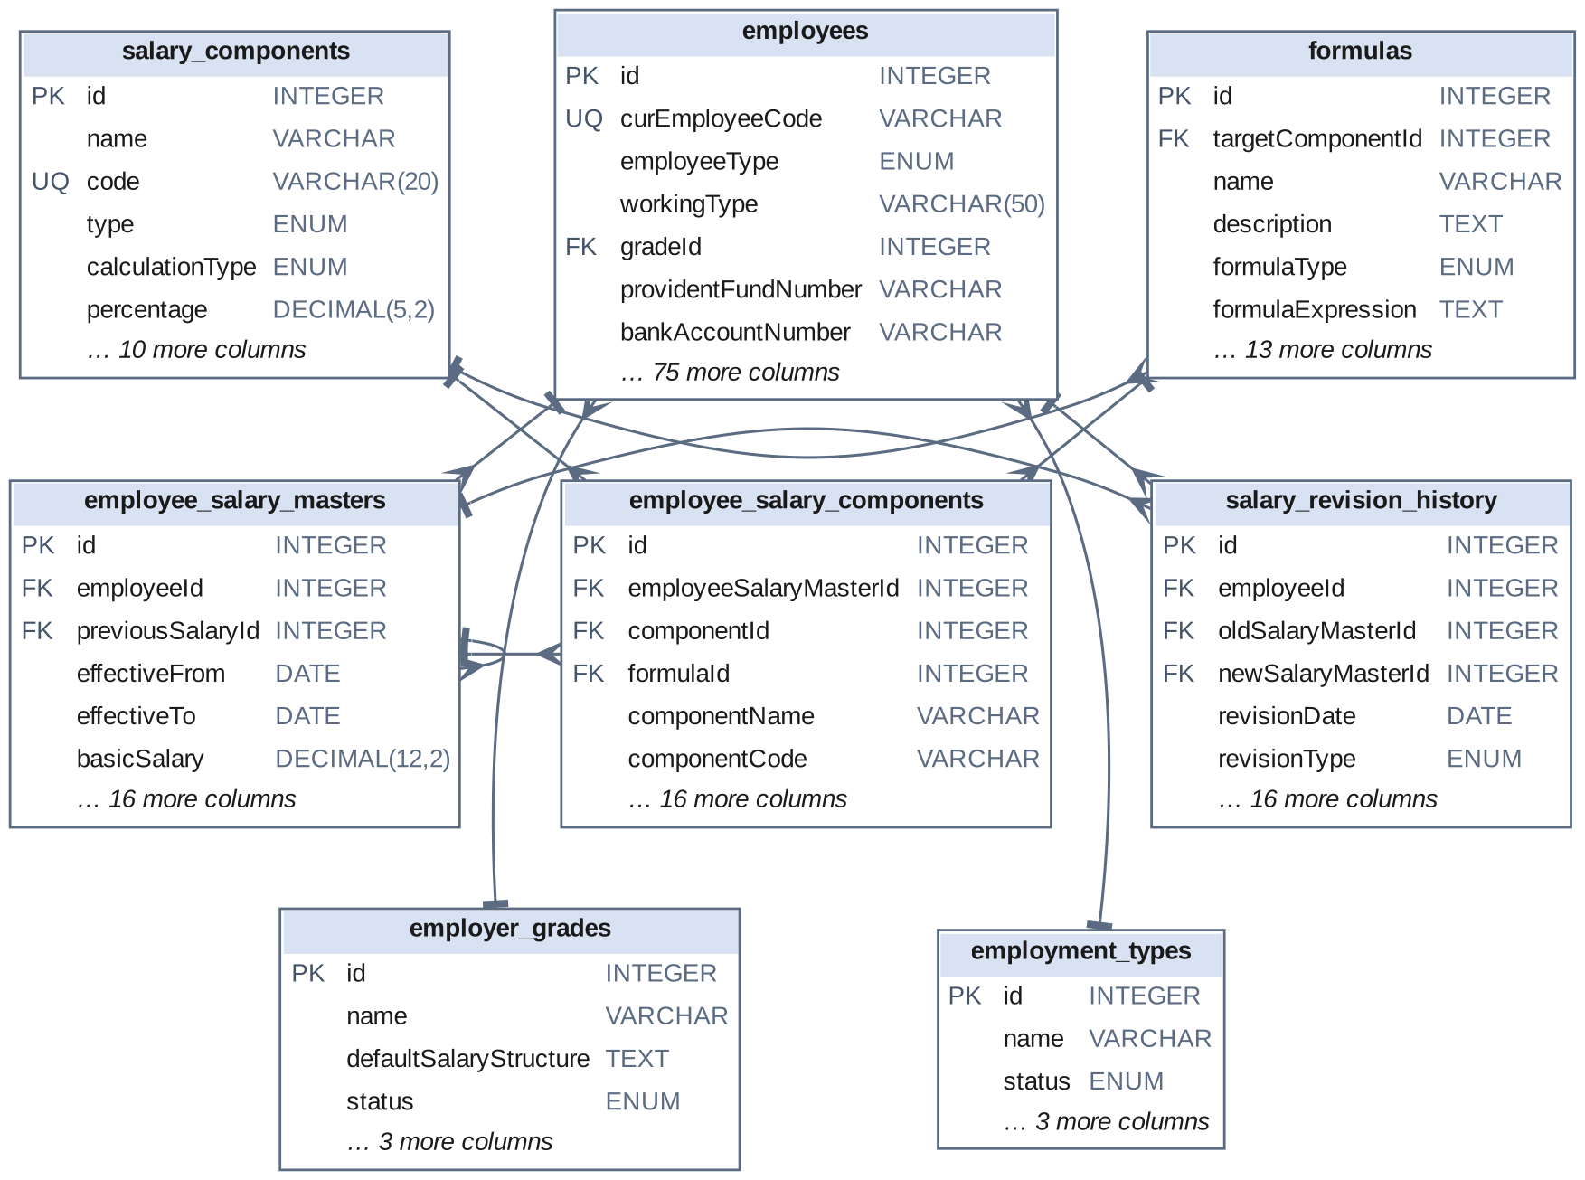
Fig 6.1 Entity-Relationship diagram – salary structure entities (companyId links to companies omitted for clarity)
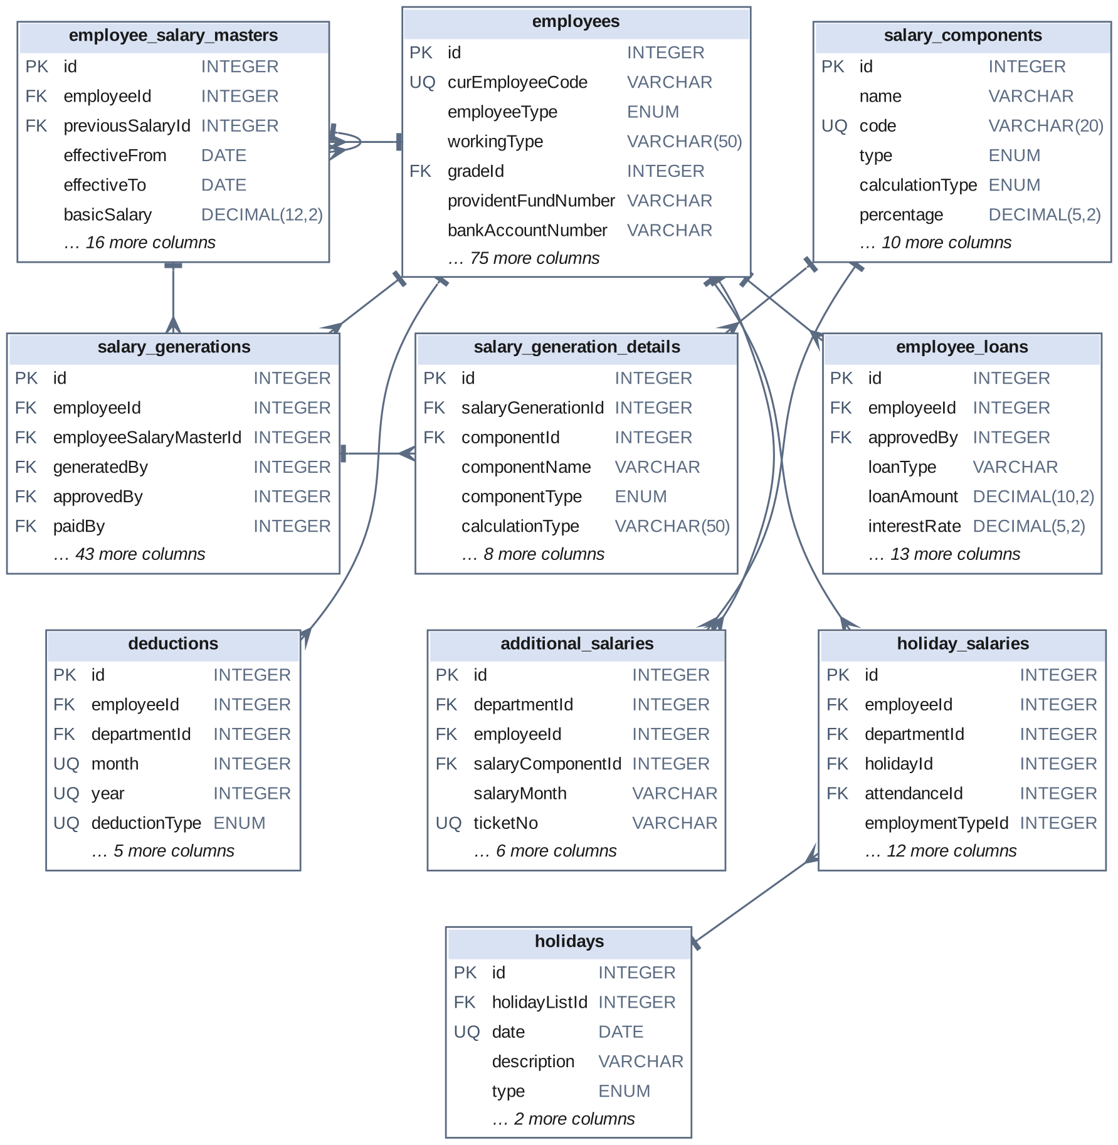
Fig 6.2 Entity-Relationship diagram – payroll processing entities (generation, details, loans, deductions, supplemental pay)
ADDITIONAL MASTER TABLES
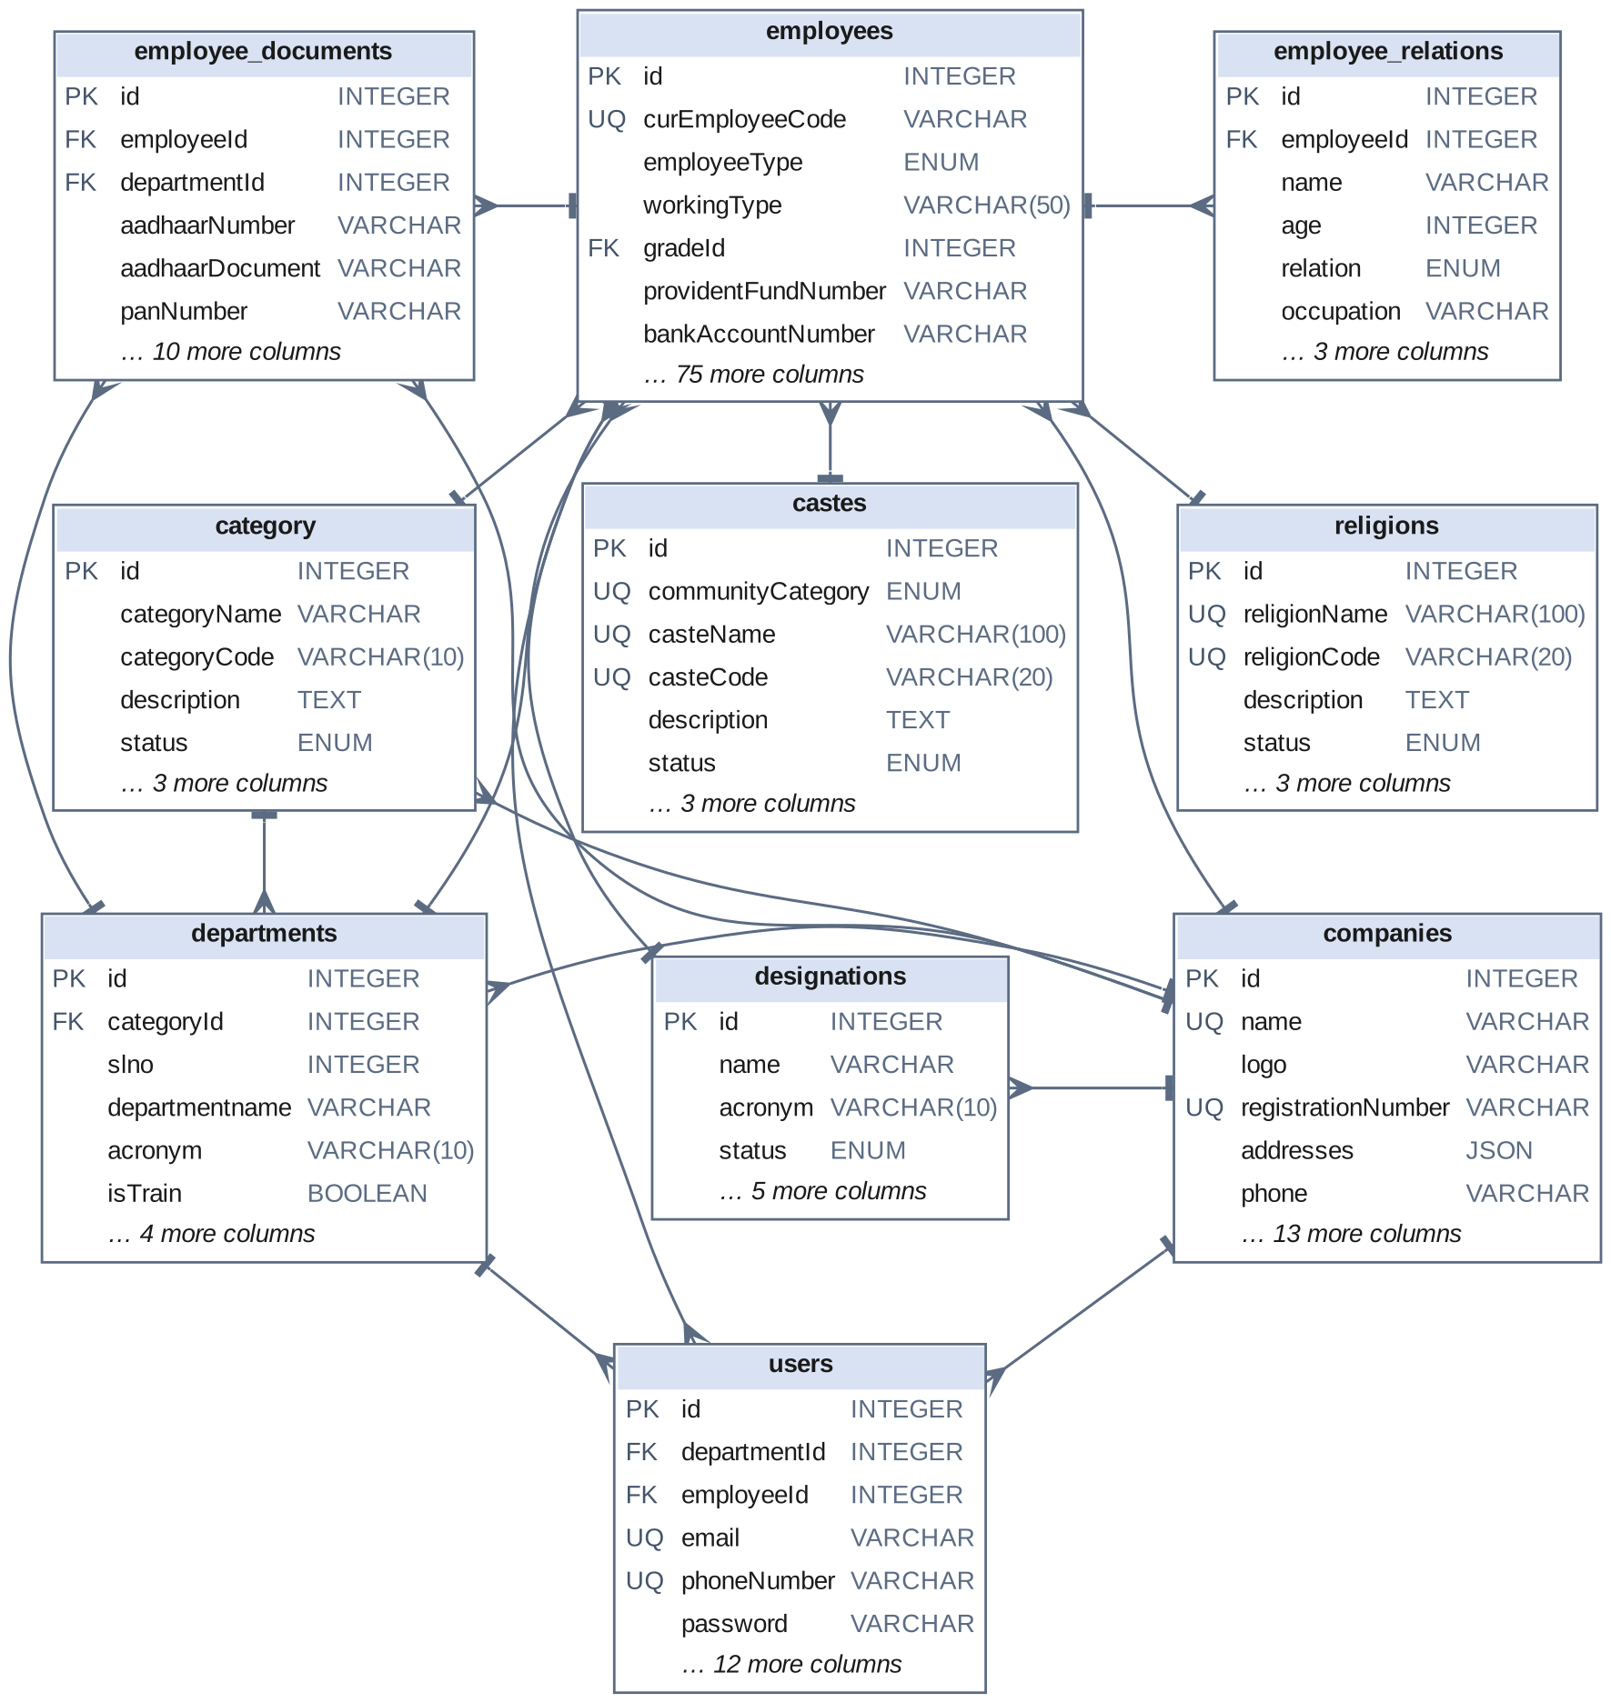
Fig 6.3 Entity-Relationship diagram – employee profile and compliance master entities
CHAPTER 7

TECH STACK

7.1 TECH STACK
Layer | Technology | Purpose
Frontend | React 19 (Vite 7) | Single-page application with dynamic UI
UI Framework | Material UI v7 + Tailwind CSS 3 | Component library and utility-first styling
Date Handling | MUI X Date Pickers + date-fns | Pay period, effective date and sanction date selection
HTTP Client | Axios | REST API communication with JWT auth
Routing | React Router DOM v7 | Protected client-side routes
Backend | Node.js + Express.js v5 | RESTful API server
ORM | Sequelize v6 | Database abstraction, model management and transactions
Database | MySQL (via mysql2) | Relational data storage
Formula Engine | formulaEvaluator.js (custom class) | Validation and evaluation of salary formulas
Payroll Configuration | config/salaryConfig.js | Single source of PF and ESI rates, ceilings and management grades
Date Arithmetic | moment | Pay periods, days in month and effective-date comparisons
Authentication | JSON Web Tokens (JWT) + jwt-decode | Stateless, token-based authentication and client-side role guards
Security | bcryptjs, CORS, payload size limit | Password hashing and HTTP request control
PDF Generation | PDFKit (server); jsPDF + jspdf-autotable (client) | Payslips, bank statements and statutory report PDFs
Excel Generation | ExcelJS (server); xlsx (client) | Salary register, bank statement and statutory report workbooks
File Upload | Multer | Employee documents and bulk uploads

7.2 ARCHITECTURE OVERVIEW
Layer | Technology | Purpose
Model | Sequelize ORM + MySQL | Defines data structure, handles DB queries, manages relationships and validations
View | React.js + Material UI | Renders the UI, manages user interaction, communicates with the server via Axios
Controller | Node.js + Express.js | Receives HTTP requests, applies business logic, coordinates between Model and View
Engine | formulaEvaluator.js, the calculators in salaryGenerationController.js, salaryConfig.js | Pure computation that turns a salary structure and a month's attendance into pay

The engine layer is what distinguishes this system from a conventional CRUD application. The formula evaluator is a self-contained class with no database access: it receives a formula string and a context of values and returns a number. The six salary calculators are likewise plain functions: each receives a salary master, a set of attendance counts and the month, and returns earnings, statutory amounts and component lines without touching the database. All reading happens before a calculator is called and all writing happens after it returns. This is what makes the pay rules testable in isolation and is why a change to how one class of employee is paid is confined to one function.
CHAPTER 8

MODULES

8.0 Design Approach
Each module of the Enterprise Payroll Engine is described here the way a system design problem is solved: by walking through the same seven steps in the same order, every time. This keeps the explanation of every module complete and comparable, and shows why each design decision was taken rather than only what the screen looks like.
Step | Question it answers | Presented in each module as
1. Functional requirements | What must the module do? | Section x.1
2. Non-functional requirements | How fast, how big, how available? Where does the CAP trade-off fall? | Section x.2
3. Tech stack | Which tools suit this problem, and why? | Section x.3
4. Back-of-the-envelope | How many users, requests and how much storage? | Section x.4
5. Low-level architecture | Which components exist and who talks to whom? | Section x.5 (diagram + request flow)
6. API design | What is the contract between client and server? | Section x.6
7. DB design | Which tables, keys and indexes store the data? | Section x.7

Shared baseline for all modules
Non-functional baseline. Every API request travels through CORS and a 50 MB payload limit before it reaches a controller, and the browser attaches the JWT bearer token to every call. All data lives in a single MySQL database, so the system chooses consistency over availability in CAP terms (CP): a user may briefly be unable to save if the database is unreachable, but two users can never see conflicting versions of a salary structure or a generated salary. For a payroll system this is not a close decision — a salary that is briefly unavailable is an inconvenience, while a salary that exists in two versions is a dispute. Money columns use DECIMAL, never floating point, so that totals reconcile exactly. Almost every table carries a companyId, making the schema multi-tenant by construction.
Sizing baseline (assumptions).
Quantity | Estimate | Basis
Employees on roll | ≈ 1,200 | One mill unit (assumption)
Named payroll users | ≈ 10 | HR, accounts and management (assumption)
Payroll runs per year | 12 | Monthly cycle
Salary components per employee | ≈ 6 | Basic, special allowance, conveyance, HRA and deductions (assumption)
Generated salaries per year | 1,200 × 12 = 14,400 | One per employee per month
Detail lines per year | 14,400 × 8 = 115,200 | ≈ 8 component lines per generated salary
Average API load | ≈ 0.1 req/s | 10 users × ≈ 300 requests over an 8-hour day
Peak load | One generation run of 1,200 employees | A single long request, a few times a month
Total tables | 23 | Model definitions

The workload of this system is unlike that of its companion. The attendance system receives thousands of small writes every day; the payroll system is almost idle for most of the month and then performs one large, computation-heavy run. The design therefore optimises for the correctness and explainability of that run rather than for request throughput. A single Node.js process and one MySQL instance handle it comfortably.
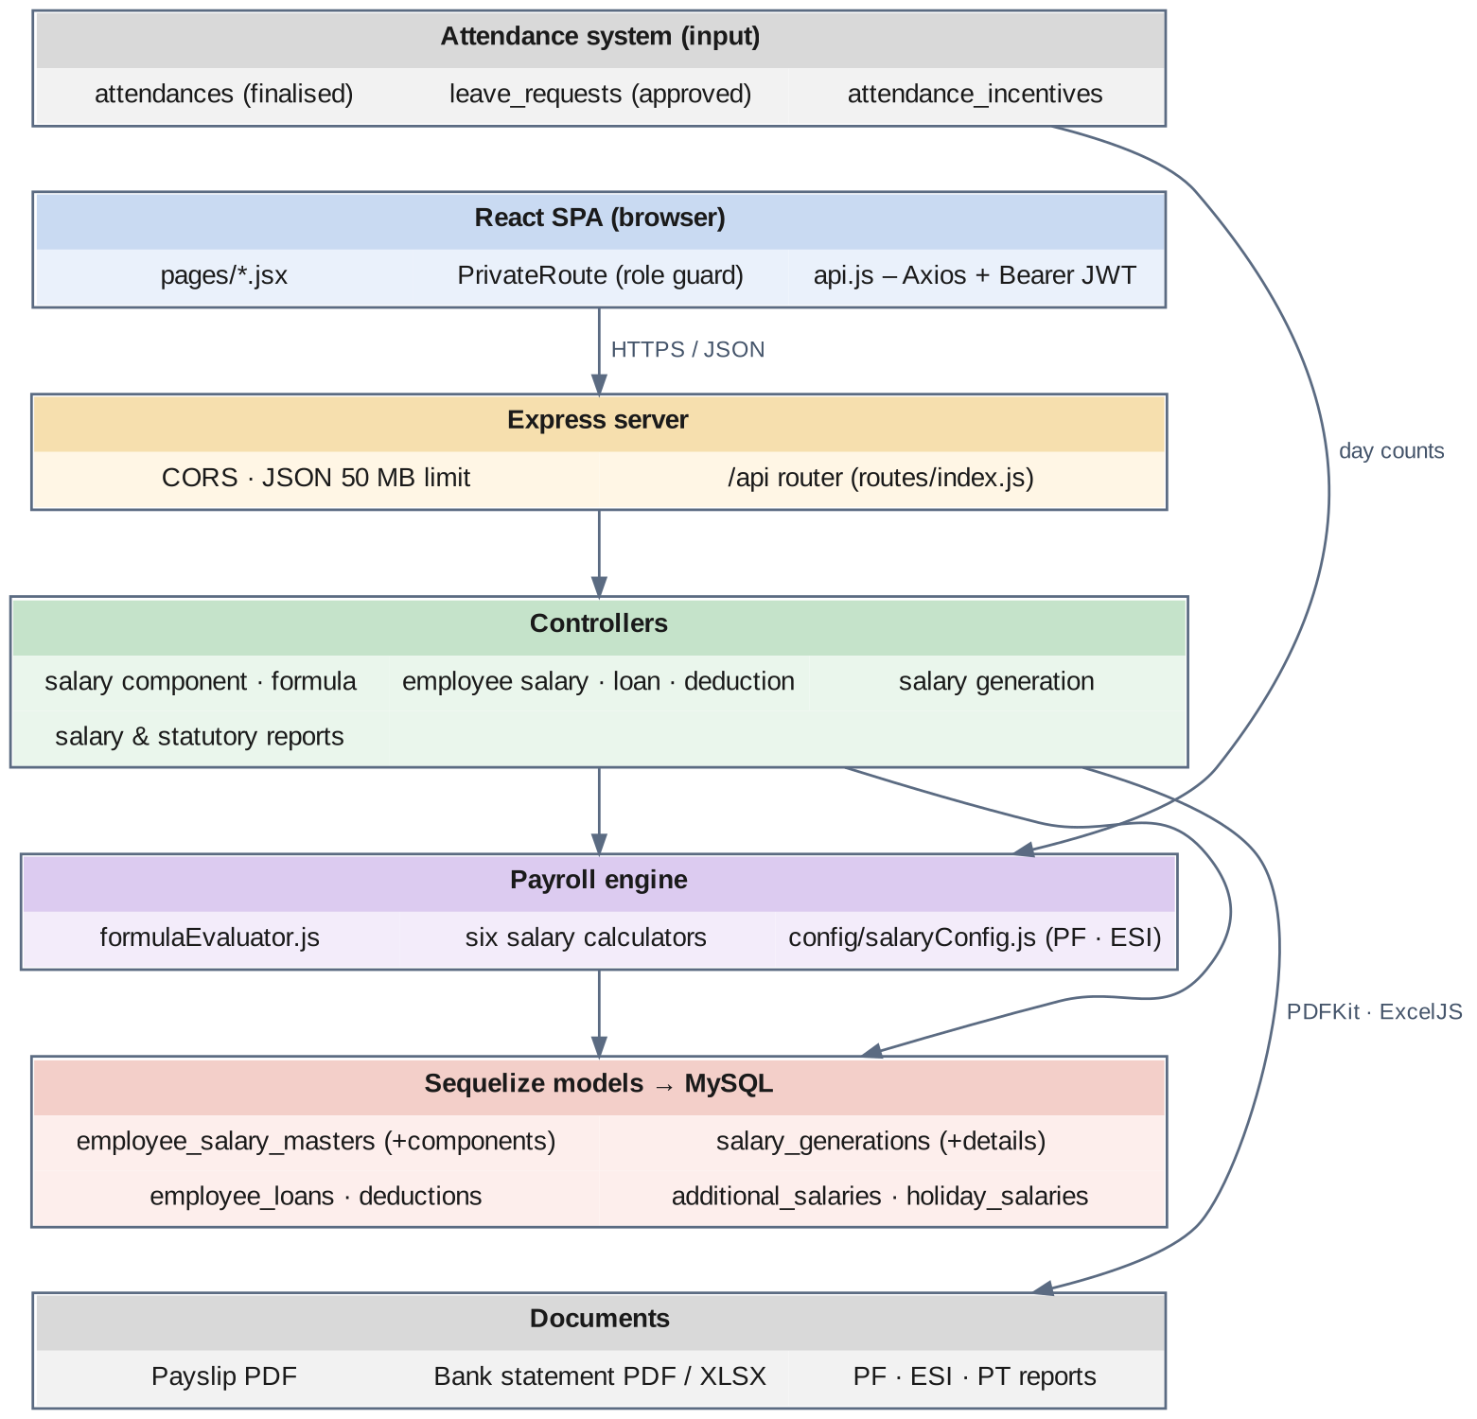
Fig 8.0 Overall request flow of the Enterprise Payroll Engine

8.1 FOLDER STRUCTURE
payroll/
├── .github/
├── .vscode/
├── backend/
├── details/
├── frontend/
├── .gitignore
└── package.json
Fig 8.1.1 High-level view of the project

8.1.1 BACKEND FOLDER
backend/
├── config/
├── controllers/
├── middleware/
├── models/
├── routes/
├── scripts/
├── services/
├── utils/
├── migrate.js
├── package.json
├── server.js
└── sync_db.js
Fig 8.1.2 Backend folder structure – overall organisation of backend files and directories showing modular architecture
The backend separates concerns into models (Sequelize model definitions), controllers (request handling and business logic, including formulaEvaluator.js and the salary calculators), routes (URL to controller mapping, assembled in routes/index.js), middleware (authentication and file upload), config (database credentials and salaryConfig.js) and uploads (stored employee documents).
backend/config/
├── database.js
├── db.js
└── salaryConfig.js
Fig 8.1.3 config folder structure – salaryConfig.js holds the PF and ESI rates, ceilings and management grades
backend/controllers/
├── additionalSalaryController.js
├── authController.js
├── casteController.js
├── categoryController.js
├── deductionController.js
├── employeeController.js
├── employeeLoan.js
├── employeeReportsController.js
├── employeeSalaryController.js
├── employerGradeController.js
├── employmentTypeController.js
├── formulaController.js
├── formulaEvaluator.js
├── holidaySalaryController.js
├── religionController.js
├── salaryComponentController.js
├── salaryGenerationController.js
├── salaryReportsController.js
├── statutoryReportsController.js
└── userController.js
Fig 8.1.4 controllers folder – controllers used by this project
backend/models/  ├── AdditionalSalary.js  ├── Caste.js  ├── Category.js  ├── Company.js  ├── Deduction.js  ├── Department.js  ├── Designation.js  ├── Employee.js  ├── EmployeeDocument.js  ├── EmployeeLoan.js  ├── EmployeeRelation.js  ├── EmployeeSalaryComponent.js | ├── EmployeeSalaryMaster.js  ├── EmployerGrade.js  ├── EmploymentType.js  ├── Formula.js  ├── HolidaySalary.js  ├── index.js  ├── Religion.js  ├── SalaryComponent.js  ├── SalaryGeneration.js  ├── SalaryGenerationDetail.js  ├── SalaryRevisionHistory.js  └── User.js
Fig 8.1.5 models folder – models used by this project
backend/routes/
├── additionalSalaryRoutes.js
├── auth.js
├── casteRoutes.js
├── categoryRoutes.js
├── deductionRoutes.js
├── employee.js
├── employeeLoan.js
├── employeeReports.js
├── employeeSalary.js
├── employerGrade.js
├── employmentType.js
├── formulaRoutes.js
├── holidaySalaryRoutes.js
├── index.js
├── religionRoutes.js
├── salaryComponent.js
├── salaryGeneration.js
├── salaryReports.js
├── statutoryReports.js
└── user.js
Fig 8.1.6 routes folder – route files used by this project

8.1.2 FRONTEND FOLDER
frontend/
├── public/
├── src/
├── .gitignore
├── eslint.config.js
├── index.html
├── package.json
├── postcss.config.js
├── README.md
├── tailwind.config.js
└── vite.config.js
Fig 8.1.7 Structure of the frontend folder
frontend/src/
├── assets/
├── pages/
├── styles/
├── utils/
├── api.js
├── App.css
├── App.jsx
├── index.css
└── main.jsx
Fig 8.1.8 Structure of frontend/src
frontend/src/pages/  ├── AdditionalSalaryManagement.jsx  ├── Auth.jsx  ├── CasteManagement.jsx  ├── CategoryManagement.jsx  ├── Dashboard.jsx  ├── DeductionManagement.jsx  ├── DeductionReport.jsx  ├── EmployeeDocuments.jsx  ├── EmployeeFormModal.jsx  ├── EmployeeLoanManagement.jsx  ├── EmployeeManagement.jsx  ├── EmployeeRelations.jsx  ├── EmployeeReports.jsx  ├── EmployeeSalaryManagement.jsx | ├── EmployerGradeManagement.jsx  ├── EmploymentTypeManagement.jsx  ├── ForgotPassword.jsx  ├── FormulaBuilder.jsx  ├── HolidaySalary.jsx  ├── Home.jsx  ├── LoginManagement.jsx  ├── ReligionManagement.jsx  ├── ResetPassword.jsx  ├── SalaryComponentManagement.jsx  ├── SalaryGenerationManagement.jsx  ├── SalaryReports.jsx  ├── StatutoryReports.jsx  └── UserManagement.jsx
Fig 8.1.9 frontend/src/pages folder – pages belonging to this project
/ → LoginManagement.jsx
employment-types → EmploymentTypeManagement.jsx
employer-grades → EmployerGradeManagement.jsx
employees → EmployeeManagement.jsx
salary-component → SalaryComponentManagement.jsx
formula-builder → FormulaBuilder.jsx
employee-salaries → EmployeeSalaryManagement.jsx
salary-generation → SalaryGenerationManagement.jsx
salary-reports → SalaryReports.jsx
employee-reports → EmployeeReports.jsx
statutory-reports → StatutoryReports.jsx
user-management → UserManagement.jsx
additional-salary → AdditionalSalaryManagement.jsx
holiday-salary → HolidaySalary.jsx
employee-loans → EmployeeLoanManagement.jsx
castes → CasteManagement.jsx
religions → ReligionManagement.jsx
categories → CategoryManagement.jsx
deduction → DeductionManagement.jsx
deduction-report → DeductionReport.jsx
documents → EmployeeDocuments.jsx
relations → EmployeeRelations.jsx
Fig 8.1.10 Route definitions in App.jsx for this project's pages (route path → page component)

8.2 USER AUTHENTICATION & ACCESS CONTROL

8.2.0 Purpose & Scope
Provides tokenized authentication, secure credential management and role-based access control, so that salary structures, generated payroll and statutory reports are reachable only by the users whose role permits it.

8.2.1 Functional Requirements
What the module must do:
- A user signs in with an email address or phone number and a password and receives a signed JWT together with a profile.
- Five roles — Super Admin, Admin, HR, Department Admin and Staff — decide which screens a user may reach. The role is carried inside the token and read by the route guard.
- A user can reset a forgotten password through a tokenized flow; the reset token and its expiry are stored on the user record and cleared on use.
- An administrator can create, update, activate, deactivate and delete user accounts and change a user's password.
- Each account has an Active / Inactive status so access can be withdrawn without deleting the record, and the last login time is stored.
- Payroll actions carry the acting user: a generated salary records who approved it and who paid it, a salary structure records who created it, and a loan records who approved it.
- The browser redirects unauthenticated users to the login screen, and removes a token that cannot be decoded.
Out of scope: self-service sign-up, multi-factor authentication, and single sign-on.

8.2.2 Non-Functional Requirements
How well the module must do it (the system-wide baseline in the chapter introduction also applies):
- Security: passwords are stored only as bcryptjs hashes with a cost factor of 10; the hash is never returned by the login response.
- No account enumeration: a failed login returns the same message whether the identifier or the password was wrong, and the forgot-password endpoint returns the same response whether or not the email exists.
- Session length: the JWT expires after seven days.
- Scalability: because tokens are stateless, any server instance can validate a request without a shared session store.
- Latency target: login under 500 ms, dominated by the deliberate cost of bcrypt.
- Enforcement layer (current state): the server-side verification middleware middleware/auth.js is implemented, and the payroll routers import it, but on those routers it is not yet switched on; role enforcement for the payroll screens currently rests on the client-side route guard. Because this system exposes salary and bank data, enabling the middleware on every payroll router is the first hardening step and is recorded in the conclusion.
- CAP: the users table is a single MySQL source of truth — consistency is preferred, so a disabled account is refused immediately on the next login.

8.2.3 Tech Stack
Concern | Choice | Why it fits this module
Password hashing | bcryptjs (salted, cost 10) | Pure JavaScript, no native build step on the production server
Session | JSON Web Token, 7-day expiry | Stateless; the client keeps the token and sends it in the Authorization header
Verification | middleware/auth.js | Parses the Bearer header, verifies the signature, attaches req.user
Password reset | Token + expiry columns on users | No extra table; the token is single-use and time-boxed
Client guard | PrivateRoute in App.jsx + jwt-decode | Reads the role from the token and redirects when the role is not in the allowed list
Token transport | Axios request interceptor in api.js | Adds the Bearer header to every call from one place

8.2.4 Back-of-the-Envelope Estimation
Quantity | Estimate | Basis
Payroll users | ≈ 10 rows, < 10 KB | Assumption (≈ 0.6 KB per row)
Logins per day | ≈ 5–10 | 7-day tokens; most users log in once a week
CPU per login | ≈ 100 ms | Typical bcrypt compare at cost 10
API calls carrying a token | ≈ 3,000 / day | 10 users × ≈ 300 requests
Token lifetime | 7 days = 604,800 s | expiresIn: "7d"

8.2.5 Low-Level Architecture
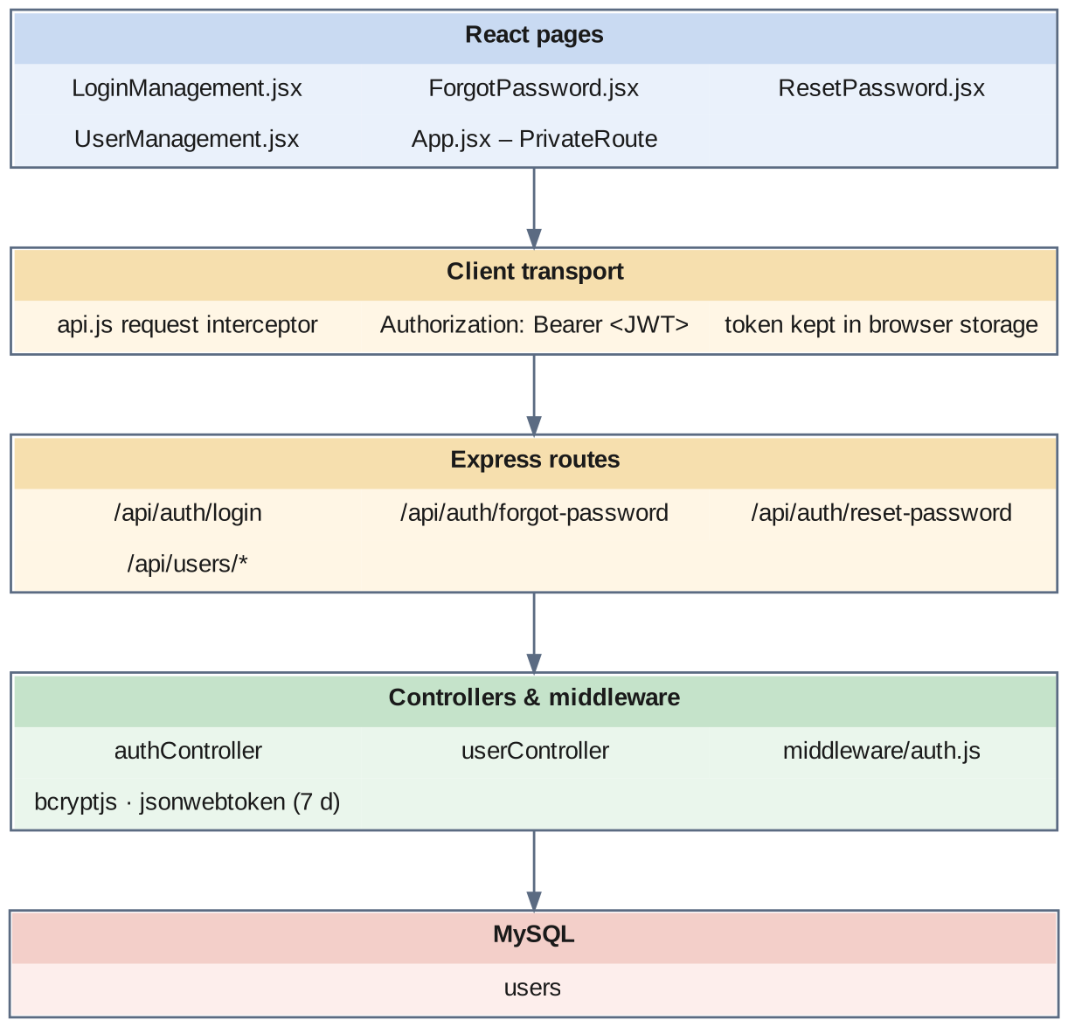
Fig 8.2.A Low-level architecture – USER AUTHENTICATION & ACCESS CONTROL
Request flow:
- LoginManagement.jsx posts the identifier and password to /api/auth/login.
- authController looks the user up by email or phone number, checks that the status is Active, and compares the password with the stored bcrypt hash.
- On success it signs a JWT carrying the user's id, role and company, valid for seven days, and returns it with the profile.
- The client stores the token in browser storage; the request interceptor in api.js adds it as a Bearer header on every later request.
- PrivateRoute in App.jsx decodes the token on each navigation. With no token, or a role outside the route's allowed list, it redirects to the login screen; a token that cannot be decoded is removed from storage.
- Payroll screens send the acting user's id with approve, pay and create actions, and the controller stores it on the record.
- For a forgotten password, ForgotPassword.jsx requests a token, which is written to passwordResetToken with passwordResetExpires; ResetPassword.jsx presents it back and the controller sets a fresh bcrypt hash and clears both columns.

8.2.6 API Design
Method | Endpoint | Purpose / contract
POST | /api/auth/login (public) | Body: identifier (email or phone), password. Returns a JWT and the user profile.
POST | /api/auth/forgot-password (public) | Body: email. Issues a reset token with an expiry.
POST | /api/auth/reset-password (public) | Body: token, new password. Stores a new bcrypt hash and clears the token.
GET | /api/users · /api/users/:id | List users; fetch one user.
GET | /api/users/email/:email · /api/users/phone/:phoneNumber | Look a user up by email or phone number.
POST | /api/users | Create a user with a hashed password and a role.
PUT | /api/users/:id | Update profile, role, company or department.
PATCH | /api/users/:id/password | Change the password.
PATCH | /api/users/:id/toggle-status | Switch an account between Active and Inactive.
DELETE | /api/users/:id | Delete a user account.

8.2.7 DB Design
Table | Keys & indexes | Key columns
users | PK id (auto) · UNIQUE email · UNIQUE phoneNumber · INDEX companyId, departmentId, role | email, phoneNumber, password (bcrypt hash), role ENUM(Staff, Admin, Department Admin, Super Admin, HR), status ENUM(Active, Inactive), firstName, lastName, lastLogin, passwordResetToken, passwordResetExpires, companyId FK, departmentId FK, employeeId FK, createdBy, updatedBy

- The unique indexes on email and phoneNumber make the login look-up an index read on either identifier and prevent duplicate accounts.
- salary_generations.approvedBy and paidBy, employee_salary_masters.createdBy and approvedBy, and employee_loans.approvedBy are how a payroll action is tied back to a user.

8.2.8 Screenshots
[ Paste screenshot here ]
Fig 8.2.1 Login screen
The login screen collects the user's email address or phone number and password and submits them to the authentication endpoint. A failed attempt returns a message without revealing whether the identifier or the password was wrong. On success the token is stored and the user is taken to the dashboard.
[ Paste screenshot here ]
Fig 8.2.2 Forgot and reset password
The user enters the registered email address to obtain a reset token and then sets a new password with it. The token is cleared once used, so the same link cannot set the password twice.
[ Paste screenshot here ]
Fig 8.2.3 User management
The user list shows each account with its role, company, department and status. Administrators withdraw access to payroll by switching an account to Inactive rather than deleting the record.

8.3 EMPLOYEE PROFILE & COMPLIANCE MASTERS

8.3.0 Purpose & Scope
Maintains the employee record as payroll needs it — how the employee is paid, where the money goes, and which statutory numbers apply — together with the identity documents, family relations and classification masters that statutory reporting depends on.

8.3.1 Functional Requirements
What the module must do:
- Create, view, edit and delete employee records through a single form organised into identity, contact, address, employment, bank and statutory sections.
- Hold the payment profile: employee type (staff or worker), working type (daily or monthly), grade, employment type, provident fund status (PF or non-PF), weekly off, and the base salary figure.
- Hold the bank profile: bank name, account number, IFSC code, branch and payment mode — the fields the bank statement reads.
- Hold the statutory numbers: UAN, EPF number and ESI number — the fields the provident fund and state insurance reports read.
- Maintain identity documents per employee: Aadhaar, PAN, passport, voter ID and driving licence, each as a number with an uploaded document file.
- Maintain family relations per employee: name, age, relation, occupation and salary. The father's or spouse's name is read by the professional tax report.
- Maintain classification masters: category, caste (grouped by community category) and religion, each scoped to a company with unique codes.
- Produce employee reports from one screen — employee details, with attendance, biometric, comprehensive, leave balance and leave taken views drawn from the attendance system's data — each exportable to Excel and PDF.
- Bulk upload employees from a file with a downloadable template and a per-row result.

8.3.2 Non-Functional Requirements
- Accuracy of the payment profile is critical. Three fields on the employee — employee type, working type and provident fund status — together with the grade decide which calculator runs. A wrong value does not cause an error; it causes a plausible but wrong salary. The form therefore offers these as fixed choices, never free text.
- Sensitive data. Bank account numbers, PAN and Aadhaar numbers live in this module. They must be visible only to payroll roles, and uploaded documents are stored on the server's file system outside the database.
- Read-heavy. The employee record is read by every payroll screen and by every employee in a generation run, and written rarely.
- Data quality. Caste and religion codes are unique within a company; a caste name is unique within its company and community category; the employee code is unique.
- Referential safety. An employee with generated salaries must not be hard-deleted; status is switched instead.
- CAP: consistency first — a corrected bank account number must be the one the next bank statement prints.

8.3.3 Tech Stack
Concern | Choice | Why it fits this module
Entry form | EmployeeFormModal.jsx with sectioned Material UI inputs | One form for a record of about eighty fields, organised so payroll fields are together
Documents | Multer upload to uploads/, path stored in employee_documents | Files stay on disk; the database holds only the reference
Relations | employee_relations child table, replaced as a set on save | A family is edited as a whole
Classification | category, castes, religions tables with per-company unique indexes | Controlled vocabularies for statutory and management reporting
Reports | employeeReportsController with ExcelJS and PDFKit | The same query feeds the screen, the workbook and the PDF

8.3.4 Back-of-the-Envelope Estimation
Quantity | Estimate | Basis
Employees | ≈ 1,200 rows ≈ 3.6 MB | ≈ 3 KB per row
Document rows | ≈ 1,200 rows | One row per employee holding five document types
Stored document files | ≈ 1,200 × 2 files × 300 KB ≈ 720 MB | Aadhaar and PAN on average (assumption)
Relation rows | ≈ 1,200 × 3 = 3,600 rows | Father, mother or spouse, and one other (assumption)
Castes / religions / categories | < 100 rows each | Small controlled lists
Reads during one generation run | 1,200 employee rows with 5 joined masters | Loaded once at the start of the run

8.3.5 Low-Level Architecture
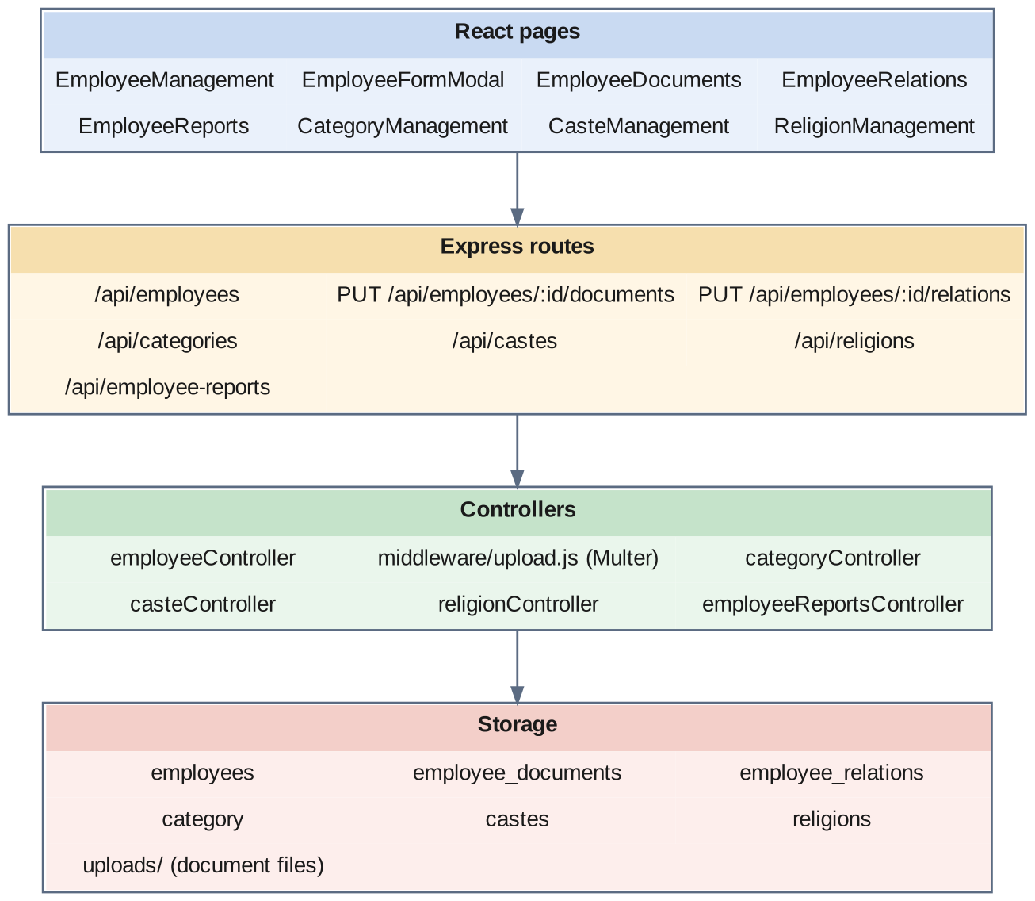
Fig 8.3.A Low-level architecture – EMPLOYEE PROFILE & COMPLIANCE MASTERS
Request flow:
- EmployeeManagement.jsx lists employees with their department, designation, grade and category.
- EmployeeFormModal.jsx creates or updates one employee; the controller validates the required fields and the unique employee code.
- EmployeeDocuments.jsx submits document numbers and files to the documents endpoint; Multer stores each file and the controller saves the numbers and file paths on the employee's document row.
- EmployeeRelations.jsx submits the family list to the relations endpoint; the controller replaces the employee's relation rows with the submitted set.
- CategoryManagement.jsx, CasteManagement.jsx and ReligionManagement.jsx maintain the classification masters; the caste screen can read castes grouped by community category.
- EmployeeReports.jsx requests the employee details report and its Excel or PDF export.
- During salary generation, the engine reads the employee with grade, designation, employment type, category and department in one query and takes the payment profile from it.

8.3.6 API Design
Method | Endpoint | Purpose / contract
GET | /api/employees · /api/employees/:id | List employees; fetch one employee.
GET | /api/employees/count/active | Count of active employees.
POST | /api/employees | Create an employee.
PUT / DELETE | /api/employees/:id | Update or remove an employee.
PUT | /api/employees/:id/documents | Save identity document numbers and uploaded files.
PUT | /api/employees/:id/relations | Replace the employee's family relations.
POST | /api/employees/bulk-upload | Create many employees from an uploaded file.
GET | /api/employees/download-template | Download the employee upload template.
GET / POST | /api/categories | List and create categories.
PUT / DELETE | /api/categories/:id | Update or remove a category.
GET | /api/castes · /api/castes/grouped · /api/castes/:id | List castes, flat or grouped by community category.
POST / PUT / DELETE | /api/castes · /api/castes/:id | Maintain castes.
GET / POST | /api/religions | List and create religions.
GET / PUT / DELETE | /api/religions/:id | Fetch, update or remove a religion.
GET | /api/employee-reports/employee-details | Employee details report with filters.
GET | /api/employee-reports/export/employee-details-excel · /employee-details-pdf | Export the employee details report.
GET | /api/employee-reports/attendance · /biometric · /comprehensive · /leave-balance · /leave-taken | The other views of the employee reports screen, each with /export/…-excel and /export/…-pdf.

8.3.7 DB Design
Table | Keys & indexes | Key columns
employees | PK id (auto) · UNIQUE curEmployeeCode · FK companyId, departmentId, designationId, employmentTypeId, gradeId, categoryId, casteId, religionId | Payroll-relevant: employeeType, workingType, gradeId, providentFundNumber (PF / NON_PF), weeklyOff, basicSalary, bankName, bankAccountNumber, ifscCode, bankBranch, paymentMode, uanNumber, epfNumber, esiNumber, dateOfJoining, status
employee_documents | PK id (auto) · FK employeeId, companyId, departmentId | aadhaarNumber / aadhaarDocument, panNumber / panDocument, passportNumber / passportDocument, voterIdNumber / voterIdDocument, drivingLicenseNumber / drivingLicenseDocument
employee_relations | PK id (auto) · FK employeeId | name, age, relation ENUM(Father, Mother, Spouse, Son, Daughter, Brother, Sister, Other), occupation, salary decimal(10,2)
category | PK id (auto) · FK companyId | categoryName, categoryCode varchar(10), description, status
castes | PK id (auto) · UNIQUE (companyId, casteCode) · UNIQUE (companyId, communityCategory, casteName) | communityCategory ENUM(General, BC, OBC, MBC, SC, ST, OC), casteName varchar(100), casteCode varchar(20), description, status
religions | PK id (auto) · UNIQUE (companyId, religionCode) · UNIQUE (companyId, religionName) | religionName varchar(100), religionCode varchar(20), description, status
companies · departments · designations | PK id (auto) | Shared organisation masters: company name and bank details, department name, designation name

- employeeType, workingType, providentFundNumber and gradeId are the four columns that route an employee to a salary calculator. They are the most consequential fields in the system.
- providentFundNumber holds the PF / NON_PF flag used to select the PF or non-PF calculator; the member's actual numbers are in uanNumber and epfNumber.
- One employee_documents row holds all five document types, which keeps a document look-up — such as the PAN for the professional tax report — to a single row read.
- The employees table is shared with the Attendance system described in the companion project. This system owns the payment, bank and statutory fields; the attendance system owns the shift and biometric fields on the same row.

8.3.8 Screenshots
[ Paste screenshot here ]
Fig 8.3.1 Employee list
The employee list shows each employee with code, name, department, designation and status, with controls to add, edit and view. It is the entry point to the employee's documents, relations and salary structure.
[ Paste screenshot here ]
Fig 8.3.2 Employee form – employment and payment details
The employment section captures the employee type, working type, grade and employment type. These fields decide which salary calculator is used, so they are offered as fixed choices.
[ Paste screenshot here ]
Fig 8.3.3 Employee form – bank and statutory details
The bank section captures the bank name, account number, IFSC code and branch, and the statutory section captures the provident fund status, UAN, EPF number and ESI number. The bank statement and statutory reports read these fields directly.
[ Paste screenshot here ]
Fig 8.3.4 Employee documents
The documents screen records Aadhaar, PAN, passport, voter ID and driving licence numbers, each with an uploaded copy. The PAN recorded here appears on the professional tax report.
[ Paste screenshot here ]
Fig 8.3.5 Employee relations
The relations screen lists family members with their relation, age and occupation. The father's or spouse's name recorded here is the one printed on the professional tax report.
[ Paste screenshot here ]
Fig 8.3.6 Category management
Categories are maintained with a name and a short code. The category is one of the filters of a payroll run and of the salary report.
[ Paste screenshot here ]
Fig 8.3.7 Caste management
Castes are maintained under a community category with a unique code. The grouped view presents them by community category for selection on the employee form.
[ Paste screenshot here ]
Fig 8.3.8 Religion management
Religions are maintained with a name and a unique code within the company. The list is small and is used as a dropdown on the employee form.
[ Paste screenshot here ]
Fig 8.3.9 Employee details report
The employee details report lists employees with their profile fields under the selected filters and exports to Excel and PDF. It is the register used to check the payment profile before a payroll run.

8.4 SALARY COMPONENTS & DYNAMIC FORMULA ENGINE

8.4.0 Purpose & Scope
Defines the catalog of earnings and deductions and the engine that validates and evaluates the formulas by which they are calculated. This module is what makes the wage structure configurable instead of coded.

8.4.1 Functional Requirements
What the module must do:
- Maintain a component catalog: each component has a name, a short code unique within the company, a type of Earning or Deduction, and a calculation type of Fixed, Percentage or Formula.
- Describe each component's effect: whether it affects gross salary, whether it affects net salary, whether it is taxable, whether it is statutory, and its display order on the payslip.
- Accept a formula written with component codes as variables — for example BASIC * 0.12 or IF(BASIC > 15000, 1800, BASIC * 0.12).
- Validate a formula before it is saved, and offer a validate endpoint so the user can check an expression while typing it.
- Provide built-in functions: IF, ROUND, MIN, MAX, ABS, FLOOR, CEIL and SWITCH, with a limited Math object and numeric conversion helpers.
- Expose employee attributes to formulas: designation, grade, experience, department, employee type, location, age, joining date, gender and qualification, so that a rule can depend on who the employee is.
- Provide formula help listing the available functions, variables and worked examples.
- Maintain a formula library through a visual builder: named formulas with a type of Simple, Conditional or Complex, the expression, a structured JSON form, the variables used, a target component, the designations and employee types it applies to, a priority, a validity period and an active flag.
- Test a formula against sample values before using it.

8.4.2 Non-Functional Requirements
- Safety is the dominant concern. A formula is text typed by a user and executed by the server. The evaluator therefore refuses a formula before it runs if it contains eval, Function, setTimeout, setInterval, require, import, export, module, process, global, window or document, any prototype-manipulation property, or access to constructor.
- Layered validation. Four independent checks run in order — dangerous patterns, balanced brackets, known identifiers, strict-mode syntax — and a formula is evaluated only after all four pass, and is validated again at evaluation time.
- Closed evaluation context. A formula is compiled as a function whose only parameters are the supplied component values, the employee attributes and the built-in helpers; it runs in strict mode and is given a reduced Math object in place of the global one.
- Numeric discipline. A numeric result is rounded to two decimal places; a result of NaN or infinity is rejected as an error and never stored as a salary.
- Honest limitation. The evaluator relies on a pattern blocklist and JavaScript's function constructor. This is appropriate for formulas written by trusted payroll administrators, but it is not a true sandbox; replacing it with a dedicated expression parser that builds and walks a syntax tree is recorded as future work.
- Determinism. The same formula and the same context always give the same amount; the evaluator holds no state between calls beyond the list of allowed component codes.
- Uniqueness. A component code is unique within a company, because the code is the variable name by which formulas refer to it.

8.4.3 Tech Stack
Concern | Choice | Why it fits this module
Formula engine | FormulaEvaluator class in controllers/formulaEvaluator.js | One self-contained class with no database access, usable from any controller
Pattern check | Regular expressions over the comment-stripped formula | Rejects dangerous constructs before anything is compiled
Identifier check | Extraction of identifiers and comparison with an allow-list | A misspelt component code is caught at save time, not on pay day
Syntax check and execution | Function constructor in strict mode with named parameters | Uses the language's own parser; the formula sees only what it is handed
Built-in functions | Closures injected into the evaluation context | IF, ROUND, MIN, MAX, SWITCH and the rest behave like spreadsheet functions payroll staff already know
Formula library | formulas table with formulaJson and variables JSON columns | Keeps the builder's structured form beside the expression text
Builder UI | FormulaBuilder.jsx | Composes an expression from components, operators and conditions

8.4.4 Back-of-the-Envelope Estimation
Quantity | Estimate | Basis
Salary components | ≈ 20 rows, < 10 KB | Earnings and deductions of one company (assumption)
Library formulas | ≈ 30 rows, < 50 KB | A few per component and employee class (assumption)
Formula length | ≈ 30–120 characters | For example IF(BASIC > 15000, 1800, BASIC * 0.12) is 37
Validation cost | 4 checks, well under 1 ms | Regular expressions and one compile
Evaluation cost | ≈ 0.05 ms per formula | One compiled function call
Evaluations per salary assignment | ≈ 2–3 | Formula-type components in a structure of ≈ 6
Evaluations for a bulk assignment of 1,200 | ≈ 3,000 ≈ 0.15 s of formula time | 1,200 × 2.5 × 0.05 ms — negligible beside database time

8.4.5 Low-Level Architecture
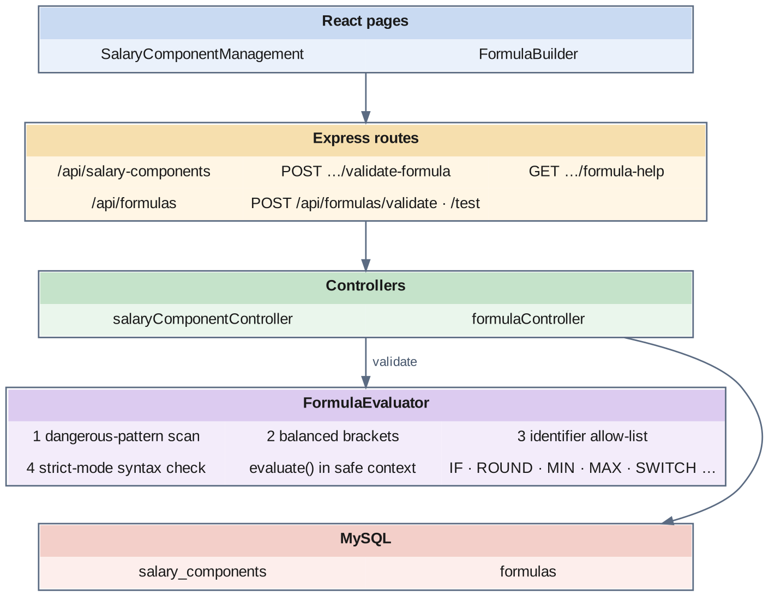
Fig 8.4.A Low-level architecture – SALARY COMPONENTS & DYNAMIC FORMULA ENGINE
Validation flow (validateFormula):
- Step 1 – Strip and scan. Block and line comments are removed, then the formula is tested against the dangerous-pattern list. Any match rejects the formula.
- Step 2 – Balance. Brackets are checked for correct opening and closing.
- Step 3 – Identifiers. Every identifier in the formula is extracted and compared with the allowed set: the company's component codes, the employee attributes, the built-in functions, the permitted methods and a few constants.
- Step 4 – Syntax. The expression is compiled in strict mode without being run; a compile error is returned to the user as a syntax error.
Evaluation flow (evaluate):
- The formula is validated again.
- createSafeContext copies the supplied values — component codes with their amounts, and the employee attributes — and adds the built-in functions, safe numeric converters and the reduced Math object.
- A function is built whose parameter names are the context keys and whose body returns the formula expression in strict mode; it is called with the context values.
- A numeric result is checked for NaN and infinity and rounded to two decimals.
Screen flow:
- SalaryComponentManagement.jsx lists components and opens the add or edit form. For a Formula component the controller loads the company's component codes into the evaluator and validates the expression before saving.
- The validate-formula endpoint returns either success or the specific error, and the formula-help endpoint returns the function list, the available variables and examples.
- FormulaBuilder.jsx loads the components, designations and employee types for the company, lets the user compose a formula, validates and tests it, and saves it to the formula library.

8.4.6 API Design
Method | Endpoint | Purpose / contract
GET | /api/salary-components · /api/salary-components/:id | List the component catalog; fetch one component.
POST | /api/salary-components | Create a component; a formula is validated before saving.
PUT / DELETE | /api/salary-components/:id | Update or remove a component.
POST | /api/salary-components/validate-formula | Body: formula, companyId. Returns valid or the validation error.
GET | /api/salary-components/formula-help | Functions, variables and examples available to formulas.
GET | /api/formulas · /api/formulas/:id | List library formulas for a company; fetch one.
GET | /api/formulas/components/:companyId | Components available as formula variables.
GET | /api/formulas/designations/:companyId | Designations a formula can be applied to.
GET | /api/formulas/employee-types/:companyId | Employee types a formula can be applied to.
GET | /api/formulas/employee/:employeeId | Formulas applicable to one employee.
POST | /api/formulas/validate | Validate a formula expression and its structure.
POST | /api/formulas/test | Evaluate a formula against sample values.
POST | /api/formulas | Save a formula to the library.
PUT / DELETE | /api/formulas/:id | Update or remove a library formula.

8.4.7 DB Design
Table | Keys & indexes | Key columns
salary_components | PK id (auto) · UNIQUE (code, companyId) · FK companyId | name, code varchar(20), type ENUM(Earning, Deduction), calculationType ENUM(Fixed, Percentage, Formula), percentage decimal(5,2), formula TEXT, affectsGrossSalary, affectsNetSalary, isTaxable, isStatutory, displayOrder, status
formulas | PK id (auto) · INDEX (companyId, isActive), targetComponentId · FK targetComponentId → salary_components | name, description, formulaType ENUM(Simple, Conditional, Complex), formulaExpression TEXT, formulaJson JSON, variables JSON, applicableDesignations JSON, applicableEmployeeTypes JSON, isActive, validFrom, validTo, priority, createdBy, updatedBy

- The unique index on (code, companyId) is what allows a component code to be used as a variable name: within a company, BASIC can only ever mean one thing.
- formulaJson stores the structured form the builder works with, beside the flat formulaExpression the evaluator runs. The expression is what is executed; the JSON is what lets the builder reopen a formula for editing.
- affectsGrossSalary is read when a salary is assigned: only earnings with this flag set are added into gross salary.
- validFrom, validTo and priority on formulas allow more than one formula to exist for the same target component, with the applicable one chosen by date and priority.

8.4.8 Screenshots
[ Paste screenshot here ]
Fig 8.4.1 Salary component list
The component catalog lists each earning and deduction with its code, type, calculation type and status. The code shown here is the name by which formulas refer to the component.
[ Paste screenshot here ]
Fig 8.4.2 Adding a fixed or percentage component
The component form captures the name, code, type and calculation type, with flags for gross, net, taxable and statutory. For a percentage component the percentage is entered here and the base is chosen when the component is assigned to an employee.
[ Paste screenshot here ]
Fig 8.4.3 Adding a formula component
When the calculation type is Formula, the form accepts an expression written with component codes. The expression is validated on save, so a component with an invalid formula cannot enter the catalog.
[ Paste screenshot here ]
Fig 8.4.4 Formula validation error
A formula that fails validation is rejected with the specific reason — an unknown identifier, unbalanced brackets, a syntax error or a disallowed construct. The user corrects the expression before the component is stored.
[ Paste screenshot here ]
Fig 8.4.5 Formula help
The help panel lists the built-in functions with their signatures, the component codes and employee attributes available as variables, and worked examples. It is drawn from the evaluator itself, so it always matches what the engine accepts.
[ Paste screenshot here ]
Fig 8.4.6 Formula builder
The formula builder composes an expression from components, operators and conditions and sets the formula's type, target component, applicable designations and employee types, priority and validity dates. The structured form is stored so the formula can be reopened and edited.
[ Paste screenshot here ]
Fig 8.4.7 Testing a formula
The test action evaluates the formula against sample values and shows the result. Trying a formula on known figures before it is used is the simplest protection against a rule that is valid but wrong.

8.5 EMPLOYEE SALARY MASTER & REVISION MANAGEMENT

8.5.0 Purpose & Scope
Assigns each employee a dated salary structure built from the component catalog, calculates its totals, and manages revisions so that the structure in force on any date — past or future — can be recovered.

8.5.1 Functional Requirements
What the module must do:
- Assign a salary structure to an employee: an effective-from date and a list of components, each Fixed, Percentage of a named base component, or Formula.
- Calculate the structure in three passes — fixed amounts, then percentages, then formulas — so that every dependent component finds its base already computed.
- Derive the totals: basic salary, gross salary (earnings that affect gross), total deductions, net salary, and monthly and annual cost-to-company.
- Refuse a second active structure: an employee who already has an Active, open-ended structure must be revised, not assigned again.
- Assign in bulk to many employees in one request, each in its own transaction, reporting success and failure per employee.
- Revise a salary with a revision type of Annual Hike, Promotion, Special Increment, Correction or Transfer: close the current structure, create the new one linked to it, and record the revision.
- Record revision history with the old and new basic, gross and cost-to-company figures, the increment amount, the increment percentage, the reason and who processed it.
- Answer three time-based questions: the current salary, the salary in force on a given date, and the full salary history of an employee.
- Maintain employer grades — including a default salary structure per grade — and employment types, the classifications that determine how an employee is paid.

8.5.2 Non-Functional Requirements
- Atomicity. Assigning a salary writes a master row, several component rows and a history row; revising additionally updates the previous master. Each operation runs in one database transaction, so a failure part-way leaves nothing behind.
- No overwriting of history. A revision never updates amounts in place. The previous structure is closed with an effective-to date and marked Superseded; the new one is a new row. This is what allows a backdated payroll run to find the salary that was valid then.
- Unambiguous current salary. The current structure is the one with status Active and no effective-to date; the assign path enforces that only one exists.
- Order independence for the user. Because calculation runs in three typed passes, the order in which the user lists the components does not change the result.
- Fail loudly. A component whose formula is invalid or cannot be evaluated aborts the whole assignment with a message naming the component, instead of saving a zero.
- Precision. Salary and cost-to-company figures are DECIMAL(12,2); percentages are DECIMAL(5,2).
- CAP: CP. A salary structure is the input to every later payroll run and must have exactly one version.

8.5.3 Tech Stack
Concern | Choice | Why it fits this module
Atomic writes | Sequelize managed transaction with commit and rollback | Master, components and history succeed or fail together
Calculation | calculateSalaryTotals() in employeeSalaryController.js | One function shared by assign, bulk assign and revise
Formula evaluation | formulaEvaluator.evaluate() with component values and employee context | Formulas can depend on other components and on who the employee is
Effective dating | effectiveFrom / effectiveTo + status on the master | A date-range model answers past, present and future questions with one query
Revision chain | previousSalaryId self-reference + salary_revision_history | The chain links structures; the history table records the figures at the moment of change
Grade defaults | defaultSalaryStructure on employer_grades | A new employee of a grade starts from the grade's standard structure

8.5.4 Back-of-the-Envelope Estimation
Quantity | Estimate | Basis
Salary masters | 1,200 active + ≈ 1,200 new per year from revisions | One revision per employee per year (assumption)
Masters after 5 years | ≈ 7,200 rows ≈ 3.6 MB | ≈ 500 bytes per row
Component rows | ≈ 6 per master → ≈ 43,200 rows after 5 years | Structure of ≈ 6 components
Revision history rows | ≈ 1,200 per year | One per revision
Writes per assignment | 1 master + 6 components + 1 history = 8 rows | In one transaction
Annual revision of the workforce | 1,200 × 9 writes ≈ 10,800 writes | 8 inserts plus closing the old master
CTC example | Gross ₹18,000 per month → ₹2,16,000 per year | ctcAnnual = ctcMonthly × 12
Increment example | Old CTC ₹2,16,000, new ₹2,37,600 → ₹21,600 = 10.00% | (new − old) ÷ old × 100

8.5.5 Low-Level Architecture
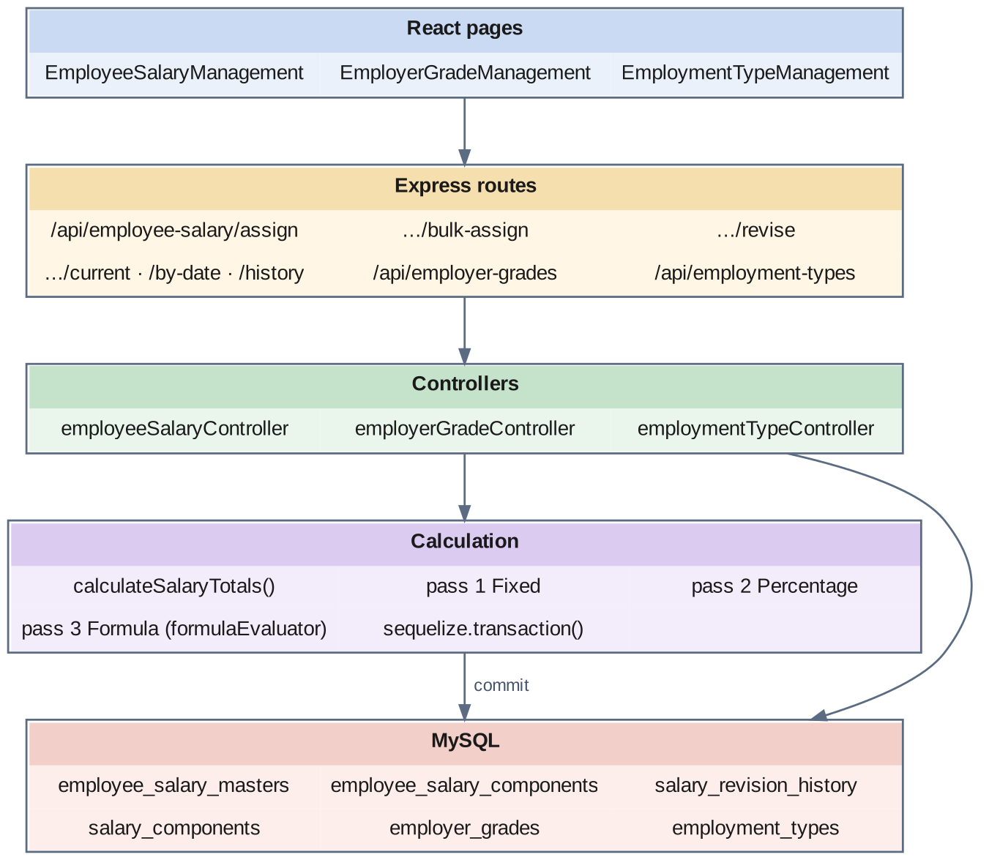
Fig 8.5.A Low-level architecture – EMPLOYEE SALARY MASTER & REVISION MANAGEMENT
Calculation (calculateSalaryTotals):
- The company's component codes are loaded into the formula evaluator as the allowed variables, and the employee is read with department, designation and grade to build the employee context.
- Pass 1 – Fixed. Each Fixed component takes its amount as given; its value is stored under its component code. A component coded BASIC, or whose name contains "basic", sets the basic salary.
- Pass 2 – Percentage. Each Percentage component is computed as the value of its base component × its percentage ÷ 100, and stored under its code.
- Pass 3 – Formula. Each Formula component is validated and then evaluated against all values computed so far merged with the employee context, and stored under its code.
- Totals. Earnings that affect gross are summed into gross salary; deductions are summed into total deductions; net is gross less deductions; monthly cost-to-company is gross and annual is twelve times that.
Assign flow:
- EmployeeSalaryManagement.jsx posts the employee, the effective date and the component list.
- Inside a transaction the controller checks that no Active open-ended structure exists, runs the calculation, inserts the master, inserts one component row per component with its calculated and annual amounts, and inserts an Initial revision history row; it then commits.
Revise flow:
- The controller reads the current Active structure inside a transaction.
- It sets that structure's effectiveTo to the day before the new effective date and its status to Superseded.
- It runs the calculation for the new components, inserts the new master with previousSalaryId pointing at the old one, and inserts its component rows.
- It computes the increment amount and percentage from the old and new annual cost-to-company and writes the revision history row, then commits.
Classification screens:
- EmployerGradeManagement.jsx and EmploymentTypeManagement.jsx maintain the grades and employment types through their own list, create, update and delete endpoints.

8.5.6 API Design
Method | Endpoint | Purpose / contract
GET | /api/employee-salary | List salary structures with filters.
GET | /api/employee-salary/current/:employeeId | The employee's current Active structure with its components.
GET | /api/employee-salary/by-date/:employeeId | The structure in force on a given date.
GET | /api/employee-salary/history/:employeeId | All structures the employee has had.
GET | /api/employee-salary/revisions/:employeeId | The employee's revision history.
POST | /api/employee-salary/assign | Body: employeeId, companyId, effectiveFrom, components. Creates the first structure.
POST | /api/employee-salary/bulk-assign | Assign structures to many employees; returns per-employee results.
POST | /api/employee-salary/revise | Body: employeeId, effectiveFrom, revisionType, components, reason. Closes the current structure and creates the next.
PUT / DELETE | /api/employee-salary/:id | Update or remove a structure.
GET / POST / PUT / DELETE | /api/employer-grades · /api/employer-grades/:id | Maintain employer grades.
GET / POST / PUT / DELETE | /api/employment-types · /api/employment-types/:id | Maintain employment types.

8.5.7 DB Design
Table | Keys & indexes | Key columns
employee_salary_masters | PK id (auto) · INDEX (employeeId, effectiveFrom), (employeeId, status), (companyId, effectiveFrom) · FK employeeId, companyId, previousSalaryId → self | effectiveFrom, effectiveTo, basicSalary, grossSalary, totalDeductions, netSalary, ctcAnnual, ctcMonthly (all decimal(12,2)), revisionType ENUM(Initial, Annual_Hike, Promotion, Special_Increment, Correction, Transfer), revisionPercentage decimal(5,2), status ENUM(Draft, Active, Superseded, Cancelled), remarks, approvedBy, approvedDate, createdBy, updatedBy
employee_salary_components | PK id (auto) · INDEX employeeSalaryMasterId, componentId, componentCode · FK employeeSalaryMasterId, componentId → salary_components, formulaId → formulas | componentName, componentCode, componentType ENUM(Earning, Deduction), valueType ENUM(Fixed, Percentage, Formula), fixedAmount decimal(10,2), percentageValue decimal(5,2), percentageBase varchar(50), formulaExpression, calculatedAmount decimal(10,2), annualAmount decimal(12,2), isStatutory, isTaxable, affectsGrossSalary, affectsNetSalary, displayOrder, remarks
salary_revision_history | PK id (auto) · INDEX (employeeId, revisionDate), revisionType, companyId · FK oldSalaryMasterId, newSalaryMasterId → employee_salary_masters | revisionDate, revisionType, oldBasicSalary / newBasicSalary, oldGrossSalary / newGrossSalary, oldCTC / newCTC, incrementAmount (decimal(12,2)), incrementPercentage decimal(5,2), reason, remarks, approvedBy, approvedDate, processedBy
employer_grades | PK id (auto) · FK companyId | name, defaultSalaryStructure TEXT, status
employment_types | PK id (auto) · FK companyId | name, status

- The index (employeeId, effectiveFrom) serves the query the payroll run depends on: the most recent structure for an employee whose effective date is on or before a given day.
- The component row copies componentName, componentCode and componentType from the catalog. A structure therefore remains readable exactly as it was assigned even if the catalog entry is later renamed.
- calculatedAmount stores the result of the three-pass calculation at assignment time. The payroll run reads this stored figure and does not re-evaluate formulas each month, which keeps a month's pay stable against later edits to a formula.
- salary_revision_history stores the old and new figures themselves, not just pointers to the two masters, so a revision letter can be produced from one row.
- The names of employer grades matter to the engine: the management grades listed in salaryConfig.js are recognised by name and paid by the management calculator.

8.5.8 Screenshots
[ Paste screenshot here ]
Fig 8.5.1 Employee salary list
The salary screen lists employees with their current basic, gross, net and cost-to-company figures and the date from which the structure is effective. It shows at a glance who has a structure and who is still to be assigned one.
[ Paste screenshot here ]
Fig 8.5.2 Assigning a salary structure
The assignment form selects the employee and effective date and adds components one by one, each as a fixed amount, a percentage of a base component, or a formula. The totals update from the three-pass calculation as components are added.
[ Paste screenshot here ]
Fig 8.5.3 Calculated breakdown
The breakdown shows each component with its calculated monthly and annual amount, and the gross, deductions, net and cost-to-company totals. This is the stored result the monthly payroll run later reads.
[ Paste screenshot here ]
Fig 8.5.4 Revising a salary
The revision form captures the new effective date, the revision type, the new components and a reason. Saving closes the previous structure the day before the new one begins, so the two never overlap.
[ Paste screenshot here ]
Fig 8.5.5 Salary history and revisions
The history view lists every structure the employee has had with its effective period and status, and each revision with the old and new figures and the increment percentage. It is the record used to answer what an employee was paid at any earlier time.
[ Paste screenshot here ]
Fig 8.5.6 Bulk salary assignment
Bulk assignment applies structures to many employees in one request and reports the outcome for each. Each employee is processed in its own transaction, so one failure does not undo the others.
[ Paste screenshot here ]
Fig 8.5.7 Employer grade management
Grades are maintained with a name and a default salary structure. The grade name also determines whether an employee is treated as management by the payroll engine.
[ Paste screenshot here ]
Fig 8.5.8 Employment type management
Employment types — staff, worker, staff-per-day and supervisor — are maintained here. They classify how an employee is engaged and are used as a filter throughout payroll.

8.6 LOAN & DEDUCTION MANAGEMENT

8.6.0 Purpose & Scope
Records the amounts to be recovered from an employee's pay — loan instalments and monthly recoveries such as mess, stores, electricity and advances — and keeps each loan's repayment position up to date as payroll recovers it.

8.6.1 Functional Requirements
What the module must do:
- Record a loan with its type, amount, interest rate, sanction date, start date, number of instalments, remarks and reason.
- Derive the instalment as the loan amount divided by the number of instalments.
- Approve a loan, recording the approver and the approval date, and move it from pending to active.
- Track repayment: the number of instalments paid and the amount paid so far, and mark the loan completed when the last instalment is recovered.
- Recover automatically during payroll: every active loan with instalments remaining contributes its instalment to that month's loan deduction.
- Record monthly deductions per employee with a type of Mess, Stores, EB, Others or Advance, an amount and remarks.
- Allow one entry per type per month for an employee, so the same recovery cannot be entered twice.
- Produce a consolidated deduction report for a month, pivoted by employee with one column per deduction type, filterable by department and type.
- Produce a loan report showing loan positions.

8.6.2 Non-Functional Requirements
- No double recovery of deductions. A unique index on employee, month, year and deduction type makes a duplicate entry impossible at the database level.
- Loan state is explicit. A loan is pending, active, completed or cancelled; only active loans are recovered.
- Bounded recovery. A loan stops contributing once its paid instalments reach its number of instalments.
- Known limitation in re-running a month. The loan position is advanced each time a salary carrying a loan deduction is generated. A month that is generated and then regenerated before payment advances the position twice. Recording, per instalment, the month it was recovered for would make this idempotent and is recorded as future work; until then a month containing loan recoveries should be regenerated with care.
- Interest. The interest rate is stored with the loan, and the instalment is currently an equal division of the principal; interest-bearing schedules are noted as an extension.
- Precision. Loan and deduction amounts are DECIMAL(10,2); the interest rate is DECIMAL(5,2).
- CAP: CP. A deduction entered before the run must be the one the run reads.

8.6.3 Tech Stack
Concern | Choice | Why it fits this module
Loan lifecycle | status ENUM(pending, active, completed, cancelled) on employee_loans | The engine's question — "is this loan recoverable?" — is a single column test
Repayment position | paidInstallments and paidAmount counters on the loan | The outstanding balance is one subtraction, with no ledger scan
Duplicate control | Unique index (employeeId, month, year, deductionType) | The database refuses a second mess bill for the same month
Consolidated report | In-memory pivot in deductionController.getConsolidatedReport | One query, then one row per employee with a column per type
Payroll hook | getLoanEmi(), getMiscDeductions() and updateLoans() in the generation engine | Reads before the calculation, writes after it

8.6.4 Back-of-the-Envelope Estimation
Quantity | Estimate | Basis
Active loans | ≈ 120 | Roughly 10% of employees (assumption)
Loan rows per year | ≈ 150 new rows | New loans sanctioned in a year (assumption)
Instalment example | ₹20,000 over 10 instalments = ₹2,000 per month | loanAmount ÷ numberOfInstallments
Outstanding example | After 4 instalments: ₹20,000 − 4 × ₹2,000 = ₹12,000 | loanAmount − paidAmount
Deduction rows per month | ≈ 1,500 | Mess for hostel residents plus stores, EB and advances (assumption)
Deduction rows per year | ≈ 18,000 rows ≈ 4 MB | Twelve months
Loan updates per run | ≈ 120 rows | One per active loan

8.6.5 Low-Level Architecture
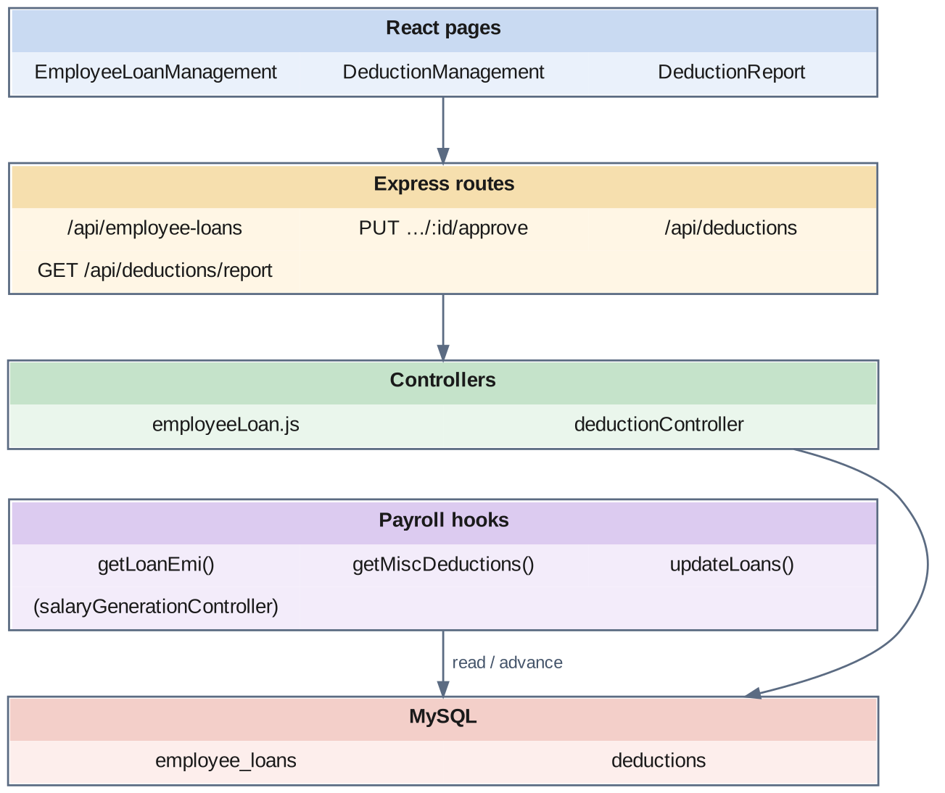
Fig 8.6.A Low-level architecture – LOAN & DEDUCTION MANAGEMENT
Request flow — loans:
- EmployeeLoanManagement.jsx posts a new loan; the controller divides the amount by the number of instalments and stores the loan as pending.
- An approver approves it; the controller sets the status to active and records the approver and date.
- During salary generation, getLoanEmi reads the employee's active loans and sums the instalment of each loan whose paid instalments are fewer than its total.
- After the salary is written, updateLoans adds one to paidInstallments and the instalment to paidAmount on each such loan, and sets the status to completed when the last instalment has been recovered.
Request flow — deductions:
- DeductionManagement.jsx posts a deduction for an employee, month, year and type; the unique index refuses a duplicate.
- During salary generation, getMiscDeductions reads the employee's deductions for the month and sorts them into mess, stores, EB, advance and other.
- DeductionReport.jsx requests the consolidated report; the controller reads the month's deductions with employee and department, groups them by employee and spreads the types across columns.

8.6.6 API Design
Method | Endpoint | Purpose / contract
GET | /api/employee-loans · /api/employee-loans/:id | List loans; fetch one loan.
POST | /api/employee-loans | Body: employeeId, loanType, loanAmount, interestRate, sanctionDate, startDate, numberOfInstallments. Creates a pending loan.
PUT | /api/employee-loans/:id | Update a loan.
PUT | /api/employee-loans/:id/approve | Body: approverId. Activates the loan.
DELETE | /api/employee-loans/:id | Remove a loan.
GET | /api/deductions | List deductions with company, month and year filters.
POST | /api/deductions | Body: employeeId, month, year, deductionType, amount.
PUT / DELETE | /api/deductions/:id | Update or remove a deduction.
GET | /api/deductions/report | Consolidated deduction report for a month, pivoted by employee.
GET | /api/statutory-reports/loan | Loan and advance position report.

8.6.7 DB Design
Table | Keys & indexes | Key columns
employee_loans | PK id (auto) · INDEX employeeId, status, sanctionDate · FK companyId, employeeId, approvedBy → employees | loanType, loanAmount decimal(10,2), interestRate decimal(5,2), sanctionDate, startDate, numberOfInstallments, installmentAmount decimal(10,2), paidInstallments, paidAmount decimal(10,2), status ENUM(pending, active, completed, cancelled), approvedDate, remarks, reason
deductions | PK id (auto) · UNIQUE unique_employee_deduction_per_month (employeeId, month, year, deductionType) · FK employeeId, departmentId, companyId | month, year, deductionType ENUM(Mess, Stores, EB, Others, Advance), amount decimal(10,2), remarks

- installmentAmount is stored rather than recomputed each month, so the recovery stays the same even if the loan's other details are later corrected.
- paidInstallments and paidAmount are counters on the loan row. The outstanding balance is loanAmount − paidAmount, available without a repayment ledger.
- The index on status lets the payroll run find recoverable loans directly.
- The unique index on deductions is the module's central integrity rule: one mess entry, one stores entry, one EB entry, one advance and one other entry per employee per month.

8.6.8 Screenshots
[ Paste screenshot here ]
Fig 8.6.1 Employee loan list
The loan list shows each loan with the employee, type, amount, instalment, instalments paid and status. The paid count against the total shows the repayment position at a glance.
[ Paste screenshot here ]
Fig 8.6.2 Creating a loan
The loan form captures the type, amount, interest rate, sanction and start dates and the number of instalments. The instalment amount is derived from the amount and the number of instalments when the loan is saved.
[ Paste screenshot here ]
Fig 8.6.3 Approving a loan
Approval moves a loan from pending to active and records who approved it and when. Only an active loan is picked up by the payroll run.
[ Paste screenshot here ]
Fig 8.6.4 Deduction entry
The deduction screen records a recovery for an employee and month under one of the five types. A second entry of the same type for the same employee and month is refused.
[ Paste screenshot here ]
Fig 8.6.5 Consolidated deduction report
The report lists each employee once, with mess, stores, EB, advance and other deductions in separate columns and a total. It is the statement checked against the mess and stores registers before payroll is run.

8.7 SUPPLEMENTAL EARNINGS: ADDITIONAL & HOLIDAY SALARY

8.7.0 Purpose & Scope
Handles earnings that fall outside the regular monthly structure — one-off additional salary credited for a month, and pay for employees who worked on a declared holiday.

8.7.1 Functional Requirements
What the module must do:
- Record additional salary for an employee and salary month against a salary component, with a number of days and an amount.
- Issue a ticket number for each additional salary entry so that it can be referred to and audited.
- Include additional salary in the month's payroll automatically, as extra earning lines on the generated salary.
- Fetch holiday attendance: for a holiday date and an employment type, list the employees who were present on that holiday.
- Compute holiday pay for workers from the employee's BASIC component in their current salary structure — the full amount for a full day present, half for a half day.
- Show staff on the same list without a pay amount, since holiday pay applies to workers.
- Mark holiday pay as paid, one entry at a time or all pending entries at once, recording when.
- Produce a monthly holiday salary report grouped by holiday, with workers covered and total pay.

8.7.2 Non-Functional Requirements
- Traceability. An additional salary entry carries a unique ticket number; a holiday salary entry links to the holiday and to the attendance row that justified it.
- No duplicate holiday pay. A unique index allows one holiday salary entry per employee per holiday.
- Dependence on upstream data. Holiday pay can only be computed for an employee who has a current salary structure containing a BASIC component; where there is none, the entry is listed without an amount instead of with a guessed one.
- Frozen figures. The basic amount and holiday pay are stored on the entry at the time it is created, so a later salary revision does not change what was owed for a past holiday.
- Precision. Amounts are DECIMAL(10,2).
- CAP: CP. An additional salary entered before the run must be included in it.

8.7.3 Tech Stack
Concern | Choice | Why it fits this module
Ticketing | Generated ticketNo with a unique column | Every supplemental credit has a reference
Payroll hook | getAdditionalSalary() in the generation engine | Rows for the month become earning lines on the generated salary
Holiday source | holidays and holiday_lists from the shared calendar | The same holiday definition the attendance system uses
Attendance source | attendances rows for the holiday date | Presence on the holiday is evidence, not a claim
Basic look-up | Current employee_salary_masters row → employee_salary_components with code BASIC | Holiday pay follows the employee's own structure
Payment tracking | status ENUM(Pending, Paid) with paidAt | Pay-one and pay-all are simple status updates

8.7.4 Back-of-the-Envelope Estimation
Quantity | Estimate | Basis
Additional salary entries per month | ≈ 50 | Occasional credits (assumption)
Additional salary rows per year | ≈ 600 rows | Twelve months
Declared holidays per year | ≈ 12 | National and festival holidays (assumption)
Employees working on a holiday | ≈ 150 | Essential shifts (assumption)
Holiday salary rows per year | 12 × 150 = 1,800 rows | Derived
Holiday pay example | BASIC ₹420 → full day ₹420, half day ₹210 | basicAmount or basicAmount ÷ 2

8.7.5 Low-Level Architecture
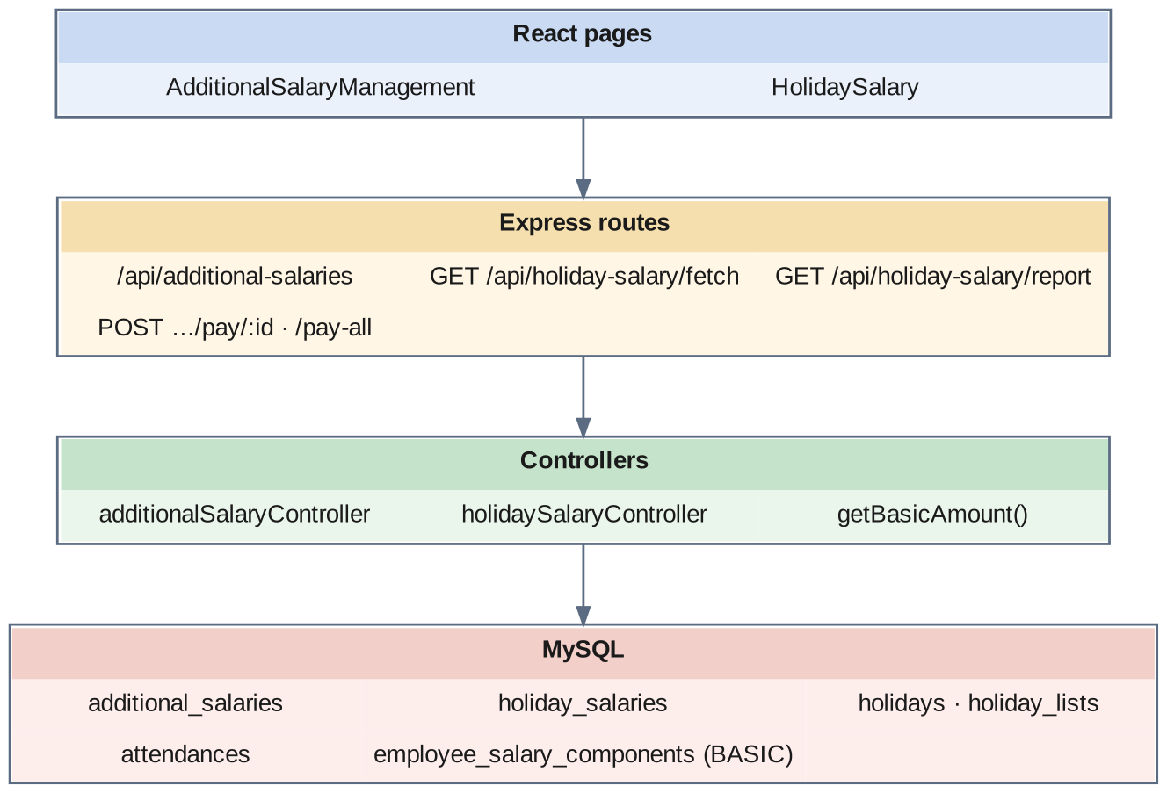
Fig 8.7.A Low-level architecture – SUPPLEMENTAL EARNINGS
Request flow — additional salary:
- AdditionalSalaryManagement.jsx posts the company, department, employee, salary month, component, days and amount.
- The controller generates a ticket number and stores the entry.
- During salary generation, getAdditionalSalary reads the employee's entries for the month, totals them, and returns each as an earning line named after its salary component; the total is added to gross and the lines are appended to the salary's details.
Request flow — holiday salary:
- HolidaySalary.jsx requests the holiday attendance for a company, a holiday date, a holiday list and an employment type.
- The controller reads the attendance rows for that date for employees of that type who were present.
- For each worker it looks up the current salary structure and its BASIC component and sets holiday pay to the full basic for a full day or half for a half day; for staff it lists the employee without an amount.
- Entries are stored as Pending; pay/:id marks one as Paid and pay-all marks every pending entry as Paid, each with the time of payment.
- The report endpoint returns the month's entries grouped by holiday with totals.

8.7.6 API Design
Method | Endpoint | Purpose / contract
GET | /api/additional-salaries | List additional salary entries.
POST | /api/additional-salaries | Body: companyId, departmentId, employeeId, salaryMonth, salaryComponentId, days, amount. Returns the entry with its ticket number.
PUT / DELETE | /api/additional-salaries/:id | Update or remove an entry.
GET | /api/holiday-salary/fetch | Query: companyId, date, holidayListId, employmentTypeId, departmentId. Employees present on the holiday with computed pay.
GET | /api/holiday-salary/report | Monthly holiday salary report grouped by holiday.
POST | /api/holiday-salary/pay/:id | Mark one holiday salary entry as Paid.
POST | /api/holiday-salary/pay-all | Mark all pending entries as Paid.

8.7.7 DB Design
Table | Keys & indexes | Key columns
additional_salaries | PK id (auto) · UNIQUE ticketNo | companyId, departmentId, employeeId, salaryMonth (YYYY-MM), salaryComponentId, days, amount decimal(10,2), status ENUM(Active, Inactive)
holiday_salaries | PK id (auto) · UNIQUE unique_employee_holiday (employeeId, holidayId) · INDEX companyId, employeeId, holidayDate, status · FK companyId, employeeId, holidayId → holidays, attendanceId → attendances | departmentId, employmentTypeId, holidayDate, holidayName, shiftName varchar(20), attendanceStatus, basicAmount decimal(10,2), holidayPay decimal(10,2), isWorker, status ENUM(Pending, Paid), paidAt

- salaryMonth is stored as a YYYY-MM string, which is exactly the key the generation engine builds from the month and year it is processing.
- attendanceId on a holiday salary entry points at the attendance row that shows the employee was present. The entitlement can always be traced back to its evidence.
- basicAmount and holidayPay are copied onto the entry. They record what was owed on that holiday at the salary then in force.
- isWorker is stored so that the report can separate workers, who are paid for the holiday, from staff, who are only listed.

8.7.8 Screenshots
[ Paste screenshot here ]
Fig 8.7.1 Additional salary list
The additional salary screen lists each entry with its ticket number, employee, month, component, days and amount. The ticket number is the reference quoted when an entry is queried.
[ Paste screenshot here ]
Fig 8.7.2 Adding additional salary
The form selects the department, employee, salary month and component and takes the days and amount. An entry saved for a month is picked up by that month's payroll run without further action.
[ Paste screenshot here ]
Fig 8.7.3 Holiday attendance and pay
The holiday screen lists the employees present on the selected holiday with their attendance status and, for workers, the basic amount and the holiday pay computed from it. A half day is shown at half the basic.
[ Paste screenshot here ]
Fig 8.7.4 Marking holiday pay as paid
Entries can be paid one at a time or all together, and each records when it was paid. The status column separates what is still owed from what has been settled.
[ Paste screenshot here ]
Fig 8.7.5 Holiday salary report
The monthly report groups entries by holiday and shows the workers covered and the total pay for each. It is the summary used to reconcile holiday pay for the month.

8.8 BATCH SALARY GENERATION PIPELINE

8.8.0 Purpose & Scope
The core of the system. For a selected set of employees and one or more months, it selects the right salary structure, counts payable days, routes each employee to the correct calculator, applies statutory rules and recoveries, and writes an explainable, status-controlled salary record.

8.8.1 Functional Requirements
What the module must do:
- Run for a month or a range of months for a company; a date range is expanded into one run per calendar month.
- Filter the population by employee, department, category, employee type, working type (daily or monthly), provident fund status (PF or non-PF), and management versus other staff.
- Skip a salary that is already Paid, and replace one that is Generated or Approved.
- Select the salary structure that was in force: the most recent Active structure whose effective-from date is on or before the first day of the pay period — so that a future-dated revision is not applied early and a backdated run uses the salary valid at that time.
- Count the days from the attendance records, approved leave and the holiday calendar: present, absent, paid leave, unpaid leave, holidays, week offs, week offs worked, and national and festival holidays. A half day counts as half; a lateness beyond the monthly permission allowance of six hours converts the day to absent.
- Collect the month's other inputs: attendance incentive, loan instalments, monthly deductions and additional salary.
- Route each employee to one of six calculators: management; monthly staff; daily-rated worker with PF; daily-rated worker without PF; monthly-rated worker with PF; monthly-rated worker without PF.
- Apply provident fund and state insurance from shared configuration.
- Total the deductions and compute net pay.
- Write the result as one header row and one detail row per component, each detail carrying its base amount, its calculated amount and the formula text.
- Collect errors per employee and continue, returning counts of processed, generated and skipped employees with the list of errors.
- Approve and pay: move a salary from Generated to Approved and from Approved to Paid, recording who and when and, on payment, the payment method and reference.
- Protect paid salaries: a Paid salary cannot be regenerated or deleted.
- Summarise a month: total employees, gross, net, PF, ESI and deductions, and the count in each status.

8.8.2 Non-Functional Requirements
- Explainability. A payroll figure that cannot be explained will be disputed. Every component line stores the formula text that produced it — for example 252.00 × 24d — so a payslip can be justified from the database alone.
- One salary per employee per month. A unique index on employee, month and year makes a duplicate impossible; regeneration updates the existing row and rewrites its details.
- Fault isolation. Each employee is processed inside its own error boundary. A missing salary structure for one employee produces an entry in the error list with a clear message and does not stop the other 1,199.
- Status as a lock. The state machine — Generated → Approved → Paid — is enforced in code: only a Generated salary can be approved, only an Approved one can be paid, and a Paid one can be neither regenerated nor deleted.
- Single source of statutory truth. The PF rate, the ESI rate, the ESI wage limit, the PF wage ceiling and the monthly permission hours are constants in one file, config/salaryConfig.js, read by every calculator.
- Pure calculators. The six calculators perform no database access; they receive data and return results. All reads happen before the call and all writes after it.
- Revision safety. The salary structure is fetched per employee with an explicit effective-date filter and ordering, so the result does not depend on how many Active rows exist.
- Performance target. A run of 1,200 employees should finish within a few minutes. It runs synchronously within the request; moving it to a background job with progress reporting is recorded as future work.
- CAP: CP. A generated salary is a financial record.

8.8.3 Tech Stack
Concern | Choice | Why it fits this module
Orchestration | generateSalary() and generateForMonth() in salaryGenerationController.js | One loop over months, one loop over employees
Calculators | calcManagement, calcStaff, calcWorkerDailyPF, calcWorkerDailyNPF, calcWorkerMonthlyPF, calcWorkerMonthlyNPF | One pure function per pay class; a rule change touches one function
Statutory rules | calcPf() and calcEsi() over constants from config/salaryConfig.js | Rates and ceilings are defined once
Day counting | getAttendanceMetrics() over attendances, approved leave_requests and the holiday map | Converts daily statuses into payable-day counts
Parallel input fetch | Promise.all over incentive, loan, deduction and additional-salary look-ups | Four independent reads issued together per employee
Idempotent write | Unique index (employeeId, salaryMonth, salaryYear) + update-or-create | Regeneration replaces, never duplicates
Small cache | Management grade ids cached for 60 seconds | Avoids re-reading the grade list for every employee
Date arithmetic | moment | Days in month, pay period boundaries, weekday names

8.8.4 Back-of-the-Envelope Estimation
Quantity | Estimate | Basis
Employees per run | ≈ 1,200 | Full company run
Reads per employee | ≈ 9 queries | Existing salary, salary master, attendance, leave, incentive, loans, deductions, additional salary, plus grade cache
Attendance rows read per employee | ≈ 30 | One per day of the month
Attendance rows read per run | 1,200 × 30 = 36,000 | Derived
Writes per employee | 1 header + ≈ 8 details ≈ 9 rows | One row per component line plus deductions
Writes per run | 1,200 × 9 ≈ 10,800 rows | Derived
Time per employee | ≈ 50–100 ms | Dominated by sequential queries
Time per run | 1,200 × 75 ms ≈ 90 s | Sequential processing
Header rows per year | 14,400 rows ≈ 10 MB | ≈ 700 bytes per row
Detail rows per year | ≈ 115,200 rows ≈ 30 MB | ≈ 250 bytes per row
PF example | Basic earned ₹18,000 → min(18,000, 15,000) × 12% = ₹1,800 | PF_BASIC_CEILING, PF_RATE
ESI example | Basic + special ₹14,000 → ⌈14,000 × 0.75%⌉ = ₹105; above ₹21,000 → ₹0 | ESI_RATE, ESI_GROSS_LIMIT

8.8.5 Low-Level Architecture
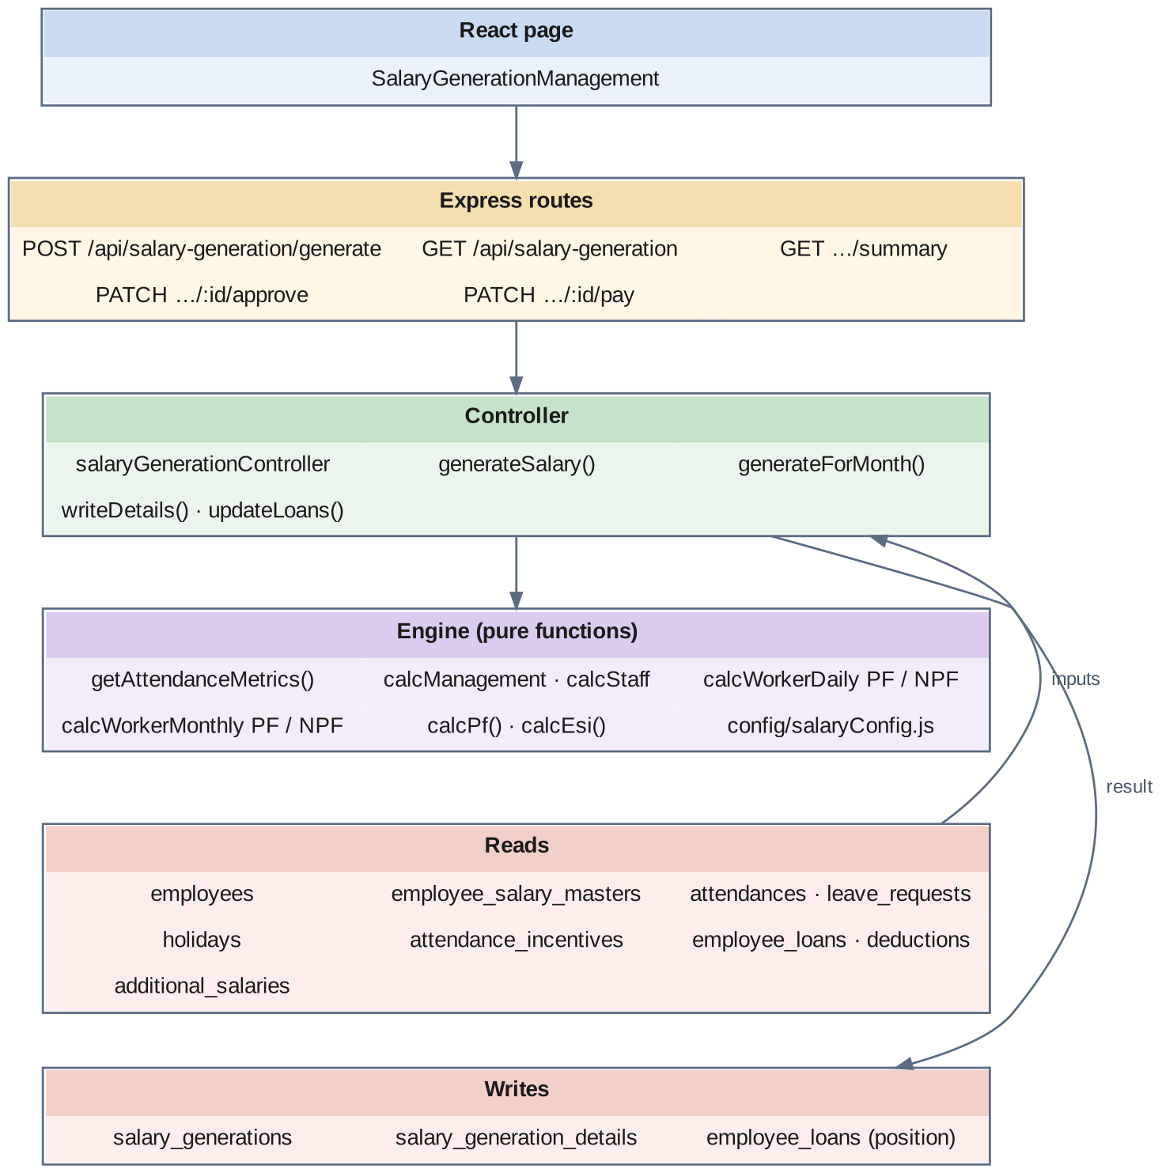
Fig 8.8.A Low-level architecture – BATCH SALARY GENERATION PIPELINE
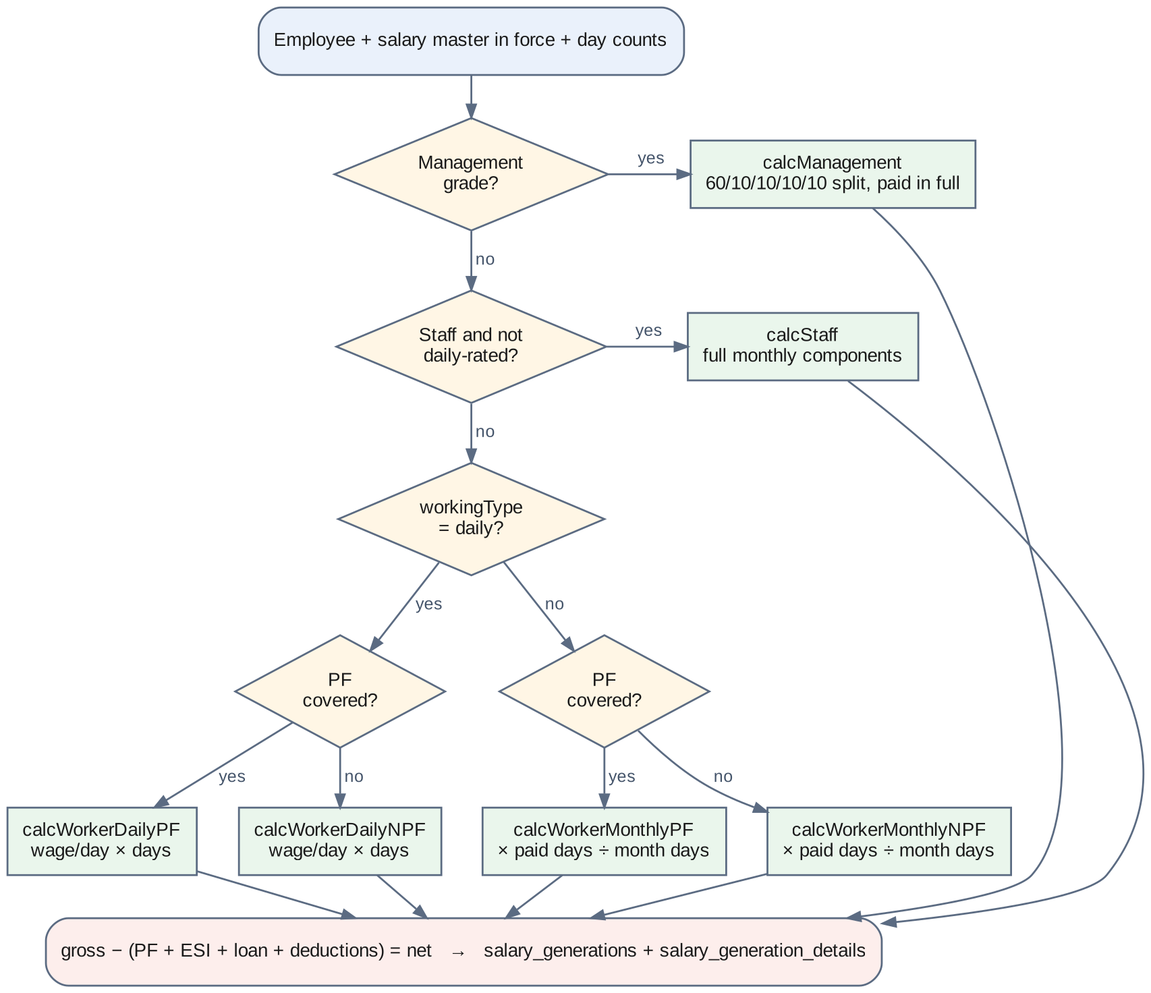
Fig 8.8.B Routing of an employee to one of the six calculators
SalaryGenerationManagement.jsx posts the run request with the company, the period and the filters, and afterwards lists the generated salaries with their approve, pay and delete actions.
Pipeline for each month:
- Step 1 – Select. The employees matching the filters are read once with grade, designation, employment type, category and department. The holiday map for the pay period is built.
- Step 2 – Guard. For each employee, an existing salary for the month is looked up. If it is Paid, the employee is skipped.
- Step 3 – Salary structure. The most recent Active structure with effectiveFrom on or before the period start is read with its components. If none exists, the engine checks for a future-dated structure and raises a message that says so, naming the date.
- Step 4 – Days. getAttendanceMetrics walks the month's attendance rows. Present and Present with Permission count as one day; Half Day and Present/Leave as half; Leave is paid or unpaid according to the leave type; a holiday of type NH or FH counts as a paid day. Week offs are counted from the employee's weekly-off pattern, and work on a week off is counted separately. Each late arrival consumes whole hours from a six-hour monthly allowance; once it is exhausted, a late day is moved from present to absent.
- Step 5 – Inputs. Attendance incentive, loan instalment, monthly deductions and additional salary are fetched together.
- Step 6 – Route. A management grade goes to the management calculator. A staff employee who is not daily-rated goes to the staff calculator. A daily-rated employee goes to the daily worker calculator, with or without PF. Everyone else goes to the monthly worker calculator, with or without PF.
- Step 7 – Calculate. The chosen calculator returns basic, special allowance, gross earned, PF, ESI and the component lines.
- Step 8 – Net. Total deductions are PF + ESI + loan instalment + advance + mess + stores + EB + other; net pay is gross earned less total deductions.
- Step 9 – Write. The header row is created, or updated if one exists (its old detail rows are deleted first); the detail rows are written; and the loans are advanced.
The six calculators:
- Management. The monthly salary is split 60% basic, 10% HRA, 10% special allowance, 10% conveyance and 10% entertainment allowance, paid in full for the month. PF is 12% of the full basic with no ceiling, except one grade for which it is fixed at ₹1,800. No ESI.
- Monthly staff. Every component of the structure is paid in full for the month. PF is 12% of basic capped at the ₹15,000 ceiling; ESI is 0.75% of basic plus special allowance where that does not exceed ₹21,000.
- Daily-rated worker with PF. From the wage per day, basic is 60% and special allowance 40%, each multiplied by regular days worked. Work on a week off is paid at the full day wage and shown under conveyance. National and festival holidays are paid at twice the day wage, except for one grade. Attendance incentive and additional salary are added. PF and ESI apply.
- Daily-rated worker without PF. The same day-based earning without PF or ESI.
- Monthly-rated worker with PF. Each component is scaled by paid days ÷ days in the month, where paid days are regular present days plus week offs; conveyance is fixed; work on a week off is paid at the daily rate. PF and ESI apply.
- Monthly-rated worker without PF. The same proration without PF or ESI.

8.8.6 API Design
Method | Endpoint | Purpose / contract
POST | /api/salary-generation/generate | Body: companyId and either month + year or fromDate + toDate; optional employeeIds, departmentIds, categoryIds, employeeType, workingType, pfType, staffType. Returns counts of processed, generated and skipped, and an error list.
GET | /api/salary-generation | List generated salaries with filters.
GET | /api/salary-generation/summary | Query: companyId, month, year. Totals of gross, net, PF, ESI and deductions, and counts by status.
GET | /api/salary-generation/:id | One generated salary with its detail lines.
PATCH | /api/salary-generation/:id/approve | Generated → Approved. Body: approvedBy.
PATCH | /api/salary-generation/:id/pay | Approved → Paid. Body: paidBy, paymentMethod, paymentReference.
DELETE | /api/salary-generation/:id | Delete a salary and its details; refused when Paid.

8.8.7 DB Design
Table | Keys & indexes | Key columns
salary_generations | PK id (auto) · UNIQUE unique_employee_month_year (employeeId, salaryMonth, salaryYear) · INDEX (companyId, salaryMonth, salaryYear), status, empCategory, empSalaryType, empPfType · FK employeeId, employeeSalaryMasterId, companyId | Period: salaryMonth, salaryYear, payPeriodStart, payPeriodEnd. Days: workingDays, totalDays, presentDays, absentDays, paidLeaveDays, unpaidLeaveDays, holidayDays, weekOffDays, nhFhDays (decimal(5,2)), overtimeHours, lateCount, earlyExitCount. Earnings: basicSalary, grossSalary, totalEarnings, attnIncentive, overtimePay, bonus. Deductions: pfAmount, esiAmount, absentDeduction, leaveDeduction, loanDeduction, lateDeduction, totalDeductions. Result: netSalary, netRounded (decimal(10,2)). Class: empCategory ENUM(staff, worker), empSalaryType ENUM(daily, monthly), empPfType ENUM(pf, npf). Control: status ENUM(Draft, Generated, Approved, Paid, Cancelled), generatedBy, approvedBy, approvedAt, paidBy, paidAt, paymentMethod, paymentReference, remarks
salary_generation_details | PK id (auto) · INDEX salaryGenerationId, componentId, componentType · FK salaryGenerationId, componentId → salary_components | componentName, componentType ENUM(Earning, Deduction), calculationType varchar(50), baseAmount decimal(10,2), calculatedAmount decimal(10,2), isProrated, proratedAmount decimal(10,2), formula TEXT, remarks

- The unique index on (employeeId, salaryMonth, salaryYear) is the central guarantee of this module: an employee has exactly one salary for a month.
- employeeSalaryMasterId records which salary structure the month was generated from. If an employee is revised later, a past month still points at the structure that was actually used.
- The day counts are stored on the header. The salary can therefore be explained — and the statutory non-contributory days derived — without re-reading the attendance tables, which may by then have been corrected.
- empCategory, empSalaryType and empPfType record which calculator was used, and are indexed because the salary and statutory reports filter on them; empPfType is what separates the PF register from the non-PF register.
- formula on the detail row holds the human-readable derivation of the line. It is documentation stored with the data.

8.8.8 Screenshots
[ Paste screenshot here ]
Fig 8.8.1 Salary generation screen
The generation screen selects the company and the month or date range, with optional filters for department, category, employee type, working type and PF status. A run can therefore be made for the whole company or for a single class of employee.
[ Paste screenshot here ]
Fig 8.8.2 Generation result
After a run the screen reports how many employees were processed, generated and skipped, and lists each error with the employee and the reason. An employee without a valid salary structure appears here instead of silently missing from the payroll.
[ Paste screenshot here ]
Fig 8.8.3 Generated salary list
The list shows each generated salary with the employee, days, gross, deductions, net and status. The status column shows how far each salary has moved through approval and payment.
[ Paste screenshot here ]
Fig 8.8.4 Salary detail with component lines
The detail view shows the day counts and every earning and deduction line with its base amount, calculated amount and formula text. This is the screen used to answer an employee's question about how a figure was arrived at.
[ Paste screenshot here ]
Fig 8.8.5 Approving a salary
Approval moves a Generated salary to Approved and records the approver and time. Only an approved salary can be paid.
[ Paste screenshot here ]
Fig 8.8.6 Marking a salary as paid
Payment moves an Approved salary to Paid with the payment method and reference. From this point the salary can be neither regenerated nor deleted.
[ Paste screenshot here ]
Fig 8.8.7 Monthly summary
The summary shows total employees, gross, net, PF, ESI and deductions for the month and the number of salaries in each status. It is the figure checked against the bank statement total before disbursement.

8.9 STATUTORY COMPLIANCE & BANK DISBURSEMENT REPORTING

8.9.0 Purpose & Scope
Turns the generated salaries into the documents that leave the system — the salary register, payslips, the bank transfer statement, and the provident fund, state insurance, income tax, professional tax and loan reports.

8.9.1 Functional Requirements
What the module must do:
- Produce a salary report for a month, filtered by company, department, employee class (management, staff or worker), PF status (PF or non-PF), salary type (daily or monthly), status and employee, paged on the server, with page and grand totals and a department-wise summary, exportable to Excel and PDF.
- Offer five report layouts that differ in how total days are counted: the base salary report, with and without earned leave, and with and without week offs.
- Produce payslips: list the payslips for a month and download an individual payslip as a PDF showing the employee, the days, each earning and deduction, and net pay in figures and in words.
- Produce a bank statement listing each employee's name, bank account number, IFSC code and net pay, with a total, in PDF and Excel.
- Produce a provident fund report per employee: UAN and EPF number, gross wages, EPF wage, pension (EPS) wage and insurance (EDLI) wage each capped at ₹15,000, employee contribution at 12%, employer pension share at 8.33% of the capped wage, employer provident fund share as the remainder, and non-contributory days, with totals.
- Produce a state insurance report per employee: ESI number, total wages, employee contribution at 0.75%, employer contribution at 3.25%, and days of loss of pay, with totals.
- Produce an income tax report of tax deducted per employee.
- Produce a professional tax report for the two half-yearly periods — September to February and March to August — showing each month's gross, the six-month total and the tax according to the slab, with the father's or spouse's name and PAN.
- Produce a loan and advance report.
- Download the PF, ESI and professional tax reports as PDF and all statutory reports as one Excel workbook.
- Produce separate PF and non-PF registers from the same report by filtering on the PF class recorded on each generated salary.

8.9.2 Non-Functional Requirements
- One source of truth. Every report in this module reads salary_generations. The payslip, the bank statement and the statutory reports are different views of the same rows, which is what keeps them consistent with one another.
- Read-only. No endpoint in this module changes data. A report can be run any number of times with the same result.
- Reproducibility. Because day counts and statutory amounts are stored on the generated salary, a report for a past month gives the same figures however often it is run.
- Documents, not screens. The outputs of this module are files handed to a bank, a statutory office or an employee, generated on the server so that they are identical whoever requests them.
- Period rules enforced. The professional tax report accepts only the two closing months of the half-years and rejects any other.
- Scope of statutory output. The reports provide the contribution figures that the monthly provident fund and state insurance returns require, as on-screen reports, PDFs and Excel. Producing the returns in the exact file layouts of the government portals is recorded as an extension.
- Sensitive output. The bank statement and payslips contain account numbers and pay; these screens are guarded for payroll roles.
- CAP: CP — the reports must reflect the salaries exactly as approved.

8.9.3 Tech Stack
Concern | Choice | Why it fits this module
PDF documents | PDFKit on the server | Precise A4 layout for payslips, bank statements and statutory reports
Workbooks | ExcelJS on the server | Styled, totalled sheets that accounts staff can work with directly
Amount in words | A number-to-words helper in salaryReportsController | A payslip states net pay in words as well as figures
Statutory arithmetic | statutoryReportsController | Wage caps, contribution splits and slabs in one place
Cross-module data | Joins to employees, employee_relations, employee_documents, departments | UAN, ESI number, bank account, PAN and father's name come from the masters
Client-side export | jsPDF, jspdf-autotable and xlsx | Quick export of what is on screen

8.9.4 Back-of-the-Envelope Estimation
Quantity | Estimate | Basis
Payslips per month | ≈ 1,200 | One per generated salary
Payslip size | ≈ 30–50 KB | One A4 page of text
Bank statement rows | ≈ 1,200 | One per employee paid by transfer
Rows read per monthly report | ≈ 1,200 salary rows with joined employee | Indexed on company, month and year
Salary report page size | 100 rows → 12 pages for 1,200 employees | Default limit
Rows read for professional tax | 6 months × 1,200 = 7,200 | Half-yearly period
Employer EPS example | Wage ₹15,000 × 8.33% = ₹1,249.50 | Capped wage
Employer EPF example | ₹1,800 − ₹1,249.50 = ₹550.50 | Employee-equivalent 12% less EPS
ESI example | Wages ₹14,000: employee ₹105, employer ₹455 | 0.75% and 3.25%
Professional tax example | Six-month gross ₹72,000 → ₹1,025 | Slab ₹60,001–₹75,000

8.9.5 Low-Level Architecture
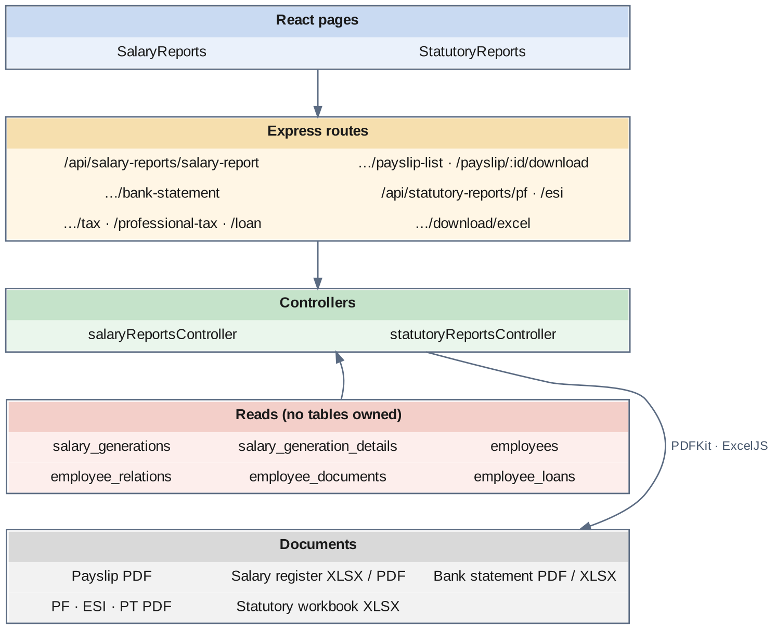
Fig 8.9.A Low-level architecture – STATUTORY COMPLIANCE & BANK DISBURSEMENT REPORTING
Request flow — salary report and payslips:
- SalaryReports.jsx requests the salary report for a month, a report layout and filters; the controller turns the filters into conditions on the salary's class columns and on the employee, reads one page of generated salaries with employee, department and component details, computes the total days for the chosen layout, the page and grand totals and a department summary, and returns them.
- The Excel and PDF endpoints build the same data into a workbook or a document and stream it back.
- The payslip list endpoint lists the month's payslips; the download endpoint builds one payslip as an A4 PDF with the company header, employee details, day counts, earnings and deductions side by side, and net pay in figures and words.
Request flow — bank statement:
- The controller reads the month's salaries with each employee's bank account number and IFSC code and returns name, account, IFSC and net pay with a total; the PDF and Excel endpoints produce the statement for the bank.
Request flow — statutory reports:
- StatutoryReports.jsx presents five tabs: EPF, ESI, Tax, Professional Tax and Loans & Advances.
- EPF. For each salary the EPF wage is taken, the EPS and EDLI wages are capped at ₹15,000, the employee contribution is 12% of the EPF wage, the employer EPS share is 8.33% of the capped wage, the employer EPF share is the difference, and non-contributory days are working days less present days.
- ESI. Employee contribution is 0.75% and employer contribution 3.25% of total wages, with days of loss of pay.
- Professional Tax. The six months of the selected half-year are read, each month's gross is placed in its column, and the tax is taken from the slab for the six-month total: nil up to ₹20,000; ₹135 up to ₹30,000; ₹315 up to ₹45,000; ₹690 up to ₹60,000; ₹1,025 up to ₹75,000; and ₹1,250 above. The father's or spouse's name is read from the employee's relations and the PAN from the employee's documents.
- Each tab offers a PDF download where available, and one endpoint produces all statutory reports as an Excel workbook.

8.9.6 API Design
Method | Endpoint | Purpose / contract
GET | /api/salary-reports/salary-report | Query: companyId, month, year, departmentId, category, pfType, salaryType, status, search, reportType, page, limit. Returns rows, page total and grand total.
GET | /api/salary-reports/salary-report/download/excel · /download/pdf | Salary report as a workbook or PDF.
GET | /api/salary-reports/payslip-list | Payslips available for a month.
GET | /api/salary-reports/payslip/:id/download | One payslip as a PDF.
GET | /api/salary-reports/bank-statement | Bank transfer statement for a month.
GET | /api/salary-reports/bank-statement/download/pdf · /download/excel | Bank statement as a PDF or workbook.
GET | /api/statutory-reports/pf | Provident fund report. Query: companyId, departmentId, month, year.
GET | /api/statutory-reports/pf/download/pdf | Provident fund report as a PDF.
GET | /api/statutory-reports/esi | State insurance report.
GET | /api/statutory-reports/esi/download/pdf | State insurance report as a PDF.
GET | /api/statutory-reports/tax | Income tax deducted per employee.
GET | /api/statutory-reports/professional-tax | Half-yearly professional tax report (February or August).
GET | /api/statutory-reports/professional-tax/download/pdf | Professional tax report as a PDF.
GET | /api/statutory-reports/loan | Loan and advance report.
GET | /api/statutory-reports/download/excel | All statutory reports as one workbook.

8.9.7 DB Design
This module owns no tables. It reads the tables below.
Table | Read for | Columns used
salary_generations | Every report | salaryMonth, salaryYear, status, workingDays, presentDays, basicSalary, grossSalary, pfAmount, esiAmount, loanDeduction, totalDeductions, netSalary, netRounded, empCategory, empSalaryType, empPfType
salary_generation_details | Salary report, payslip | componentName, componentType, calculatedAmount, formula
employees | Every report | curEmployeeCode, newEmployeeCode, firstName, lastName, dateOfJoining, uanNumber, epfNumber, esiNumber, bankAccountNumber, ifscCode, providentFundNumber
employee_relations | Professional tax | name, relation (Father or Spouse)
employee_documents | Professional tax | panNumber
departments · designations · companies | Grouping and headers | departmentname, name
employee_loans | Loan report | loanAmount, installmentAmount, paidInstallments, paidAmount, status

- Owning no tables is the design. A statutory figure that was stored separately from the salary it came from could drift from it; a figure derived on request cannot.
- The composite index (companyId, salaryMonth, salaryYear) on salary_generations serves every monthly report in this module.
- The professional tax report is the clearest example of the masters paying off: it draws the PAN from employee_documents and the father's or spouse's name from employee_relations, neither of which payroll itself ever needed.
- The report code and the generation code are being aligned on a single set of column names for gross pay and the earnings breakdown; consolidating the statutory arithmetic into the shared salaryConfig.js constants is listed in the conclusion.

8.9.8 Screenshots
[ Paste screenshot here ]
Fig 8.9.1 Salary report
The salary report lists the month's salaries with days, earnings, deductions and net pay under the selected filters, with page and grand totals. Filtering by PF status gives the PF register and the non-PF register from the same screen.
[ Paste screenshot here ]
Fig 8.9.2 Salary report export
The report downloads as an Excel workbook or a PDF with the same columns and totals. The workbook is the working copy for accounts; the PDF is the copy that is filed.
[ Paste screenshot here ]
Fig 8.9.3 Payslip list
The payslip list shows the payslips available for the month with a download action for each. Payslips are produced from the generated salary, not prepared separately.
[ Paste screenshot here ]
Fig 8.9.4 Payslip PDF
The payslip shows the company and employee details, the day counts, earnings and deductions side by side, and net pay in figures and in words. Every figure on it comes from the detail lines of the generated salary.
[ Paste screenshot here ]
Fig 8.9.5 Bank statement
The bank statement lists each employee with bank account number, IFSC code and net pay, and the total to be transferred. It is downloaded as a PDF or workbook and handed to the bank for disbursement.
[ Paste screenshot here ]
Fig 8.9.6 EPF report
The EPF tab lists each employee with UAN, EPF wage, capped pension and insurance wages, employee contribution, the employer's pension and provident fund shares and non-contributory days, with totals. These are the figures the monthly provident fund return is filled from.
[ Paste screenshot here ]
Fig 8.9.7 ESI report
The ESI tab lists each employee with ESI number, total wages, employee and employer contributions and days of loss of pay, with totals. These are the figures the monthly state insurance return is filled from.
[ Paste screenshot here ]
Fig 8.9.8 Professional tax report
The professional tax tab shows the six months of gross pay for the selected half-year, the six-month total and the tax from the slab, with the father's or spouse's name and PAN. The period selector offers only the two half-year closing months.
[ Paste screenshot here ]
Fig 8.9.9 Tax and loan reports
The tax tab totals income tax deducted per employee and the loans tab shows loan and advance positions. Both are read from the same generated salaries and loan records as the rest of the module.
CHAPTER 9

CONCLUSION
The Enterprise Payroll Engine, Dynamic Compensation & Statutory Compliance System set out to make one thing dependable: that the amount paid to each employee each month is correct, can be explained, and agrees with every statement made about it afterwards. Three design decisions carry most of that result.
The first is that the wage structure is data and not code. Earnings and deductions are catalog entries; how each is calculated is a fixed amount, a percentage or a formula; and a formula is validated in four steps before it is stored and evaluated in a closed context when it is used. A new allowance or a changed rule is therefore an administrative action. The three-pass calculation — fixed, then percentage, then formula — means the person entering a structure never has to think about the order of the components.
The second is that nothing is overwritten. A salary revision closes the previous structure with an end date and creates a new one linked to it, inside one transaction, and records the old and new figures. The monthly run selects the structure that was in force on the first day of the period, so a revision entered early does not take effect early and a backdated run finds the right salary. A generated salary records which structure it came from, the day counts it was based on, and for every line the formula that produced it.
The third is that pay rules are isolated and statutory rules are central. Six calculators, each a pure function, cover management, monthly staff, and daily-rated and monthly-rated workers with and without provident fund; a change to how one class is paid touches one function. The provident fund and state insurance rates, ceilings and limits sit in one configuration file read by all of them. And because the statutory reports, the bank statement and the payslips all read the same generated salary rows, they cannot contradict one another.
Around these decisions the system delivers a configurable component catalog and formula engine, dated salary structures with full revision history, loan and deduction recovery, additional and holiday pay, a filtered batch generation run with per-employee error reporting, a Generated–Approved–Paid lifecycle that protects settled payroll, payslips, a bank transfer statement, and provident fund, state insurance, income tax, professional tax and loan reports.
The boundary with the companion system is deliberate. This system counts payable days from the attendance records that the Smart Biometric Attendance, Shift Scheduling & Workforce Tracking System produces and finalises; it does not capture punches, detect shifts or approve leave. That separation keeps each system's responsibility small enough to reason about, and means a dispute about a day is settled in one system and a dispute about a rupee in the other.
Several limitations are worth recording honestly. The formula evaluator relies on a blocklist and JavaScript's function constructor, which suits trusted administrators but is not a true sandbox. The server-side JWT middleware is implemented but not yet switched on for the payroll routers, so role enforcement currently happens in the browser's route guard — the most important item to close for a system holding salary and bank data. Regenerating a month that contains loan recoveries advances the loan position a second time. The generation run executes synchronously inside one request. The statutory reports provide the contribution figures but not the portal file formats, and their arithmetic is not yet drawn from the shared configuration constants. Loan instalments divide the principal equally without interest. These are identified rather than hidden, and each has a clear remediation path.
Future work follows from them: enforcing the token and role check on every payroll route; replacing the evaluator with a parser that builds and walks a syntax tree; recording each loan recovery against the month it was made for, so that regeneration is idempotent; running generation as a background job with progress reporting; generating provident fund and state insurance return files in portal format; interest-bearing loan schedules; overtime pay and bonus computation, for which the columns already exist; and an employee self-service view in which a worker can open their own payslip and see, line by line, how it was calculated.

